

**Enterprise Web Software Development**

**Comp 1640**

Team members:

Nguyễn Minh Triết

Nguyễn Huy Nhật Tân

Đỗ Thành Đạt

Trần Tuấn Thành

Phạm Mai Nhật trường

**Table of Contents**

**List of Figure**

**Group Report**

# 1. Project Introduction

The web-based system with secure role-based mechanism that collects student contributions for a yearly university magazine is to be essential and since it is through this that the magazine production process will be improved in the university. The mission of the Marketing Manager is to provide on-going support and supervision as each Faculty is supplied with a Marketing Coordinator who is in charge of administration and editorial creativity of their respective departments. Under the guidance, system, all of the students can submit their ideas and aesthetic images, which will build up a fair and comprehensive thematic publication. By limiting the submission dates to agreed dates of closure and giving updates until the original closure date, the system can guide the work through a managed process and an efficient system. Furthermore, the Terms and Conditions agreement which takes care of compliance and uses statistics for better surveillance is implemented during the course of the submission process. Through automatic email notifications, Marketing Coordinators are immediately informed of the appearance of new submissions and are tasked with responding to them within the range of a given timeframe. Beyond that, by designing this method, the System Assistants can help "Students", be "Edited" and "Published", which consequently promotes communication and the interaction of both parties, thus giving birth to cooperation. The university marketing manager has the access to all contributions but s/he cannot edit the messages, therefore connects dots between marketing strategies. In addition, administrator maintains system data such as academic years closing dates, while guest accounts that students use to study are able to see only particular reports for all Faculty depending on permissions. The system has been equipped with statistical analysis capabilities as well as a user-friendly interface designed to work on all devices. The platform thereby ensures transparency, efficiency and inclusion for everyone involved in the magazine publication process.

# 2. ERD diagram

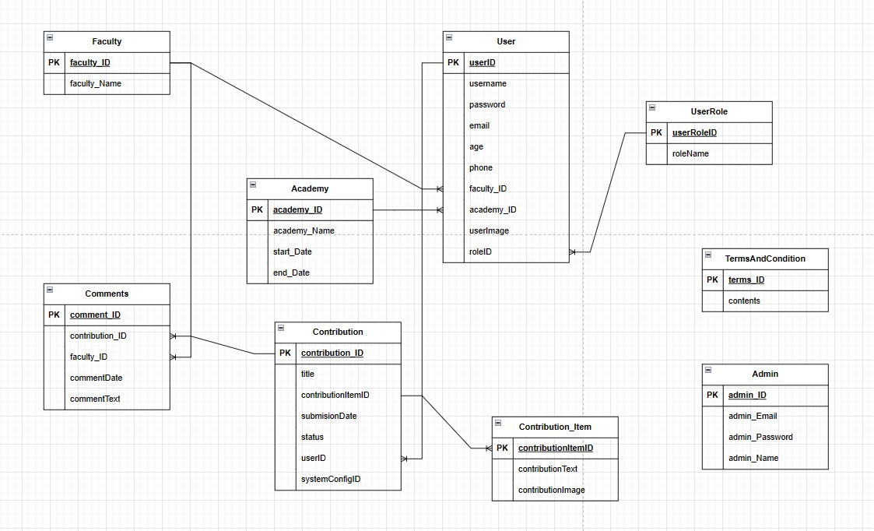

# 3. Relational Schema

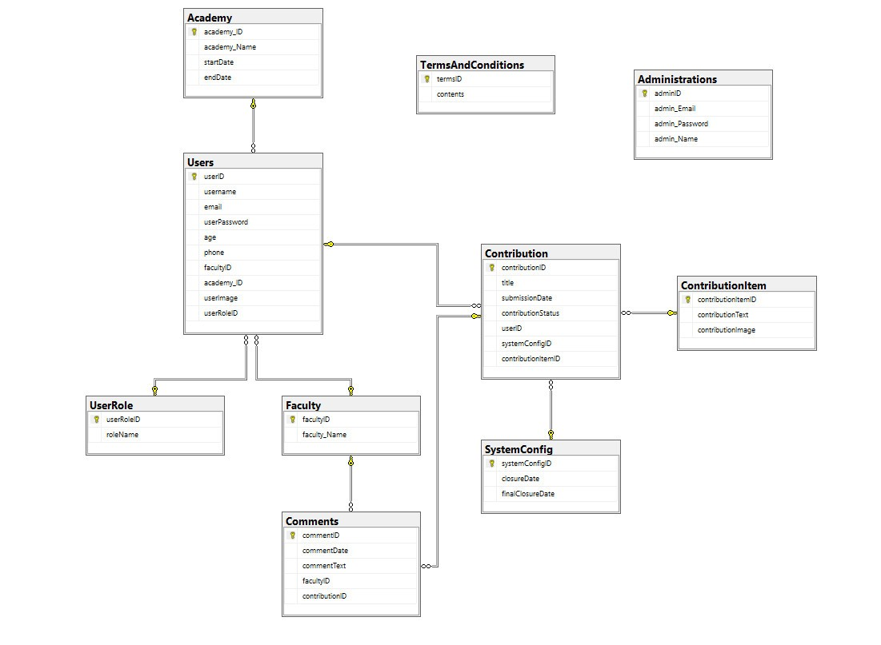

# 4. Use case diagram

Use case of student

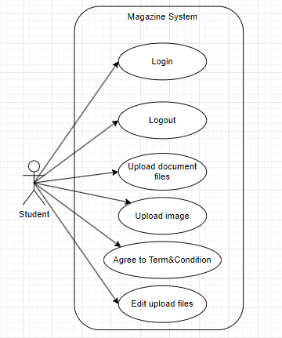

Use case of marketing coordinator

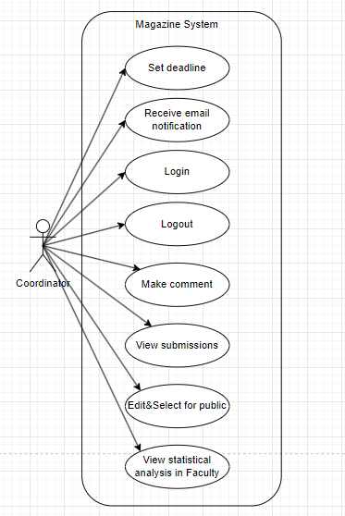

Use case of marketing manager

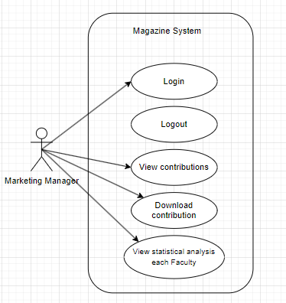

Use case of Admin

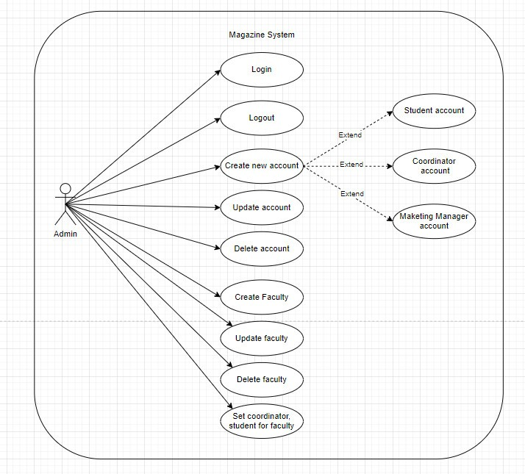

Use case of Guest

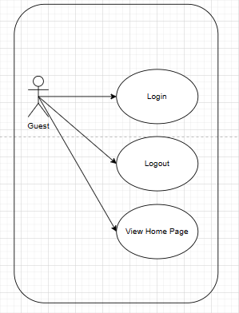

# 5. Activity diagram

The activity diagram of Students shows a stepwise approach that begins with a student login. After inputting its details, the system authenticates itself. If the student is resourceful, he/she can download an image or document after a successful submission. Authentication error is displayed and let the retry is an option to log in. Finally, irrespective of student's status of the authentication the student eventually logs out.

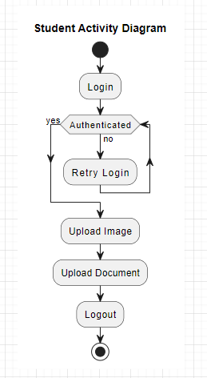

The coordinator activity diagram clearly describes the sequence that the coordinator should follow to try logging into the system. After logging in with the system, it checks if given access is approved to the coordinator. If successful, the coordinator of the petitions becomes the owner of a few duties, namely reading in entries, editing the written contributions, leaving comments, and publication of the submissions. Should the authentication fail, the system will display information on how to do the same action again. Finally, the coordinator logs out, where authentication issue ceases to matter.

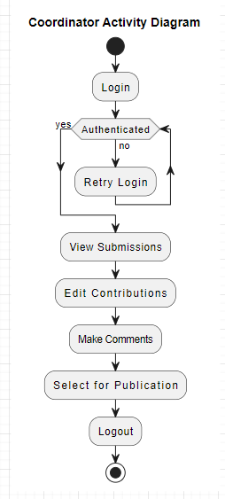

This activity diagram shows what a marketing manager goes through to bring together ideas and hand them over to the departments concerned. The supervisor opens the system and sees a list from which he can separately select the contributions, by several methods. This would enable them to pick contributions of their choice and download them for further examination. Use our AI to write for you about any topic! Enjoy Ultimately, upon finishing the review stage, the employee logs out of the online system. This diagram can be used to comprehend the workflow of the process, but it does not pinpoint exact channels or any constraints.

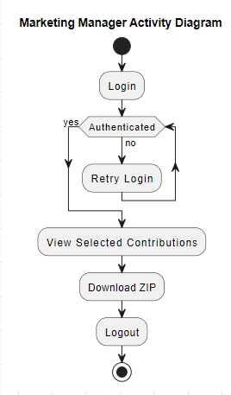

The Admin Activity Diagram reveals how an admin navigates the system after providing a login. In the first step the user enter a name and password which will be inspected for authentication. After that, the admin can leverage the data in the system to view reports, manage accounts and publications, and finally log out. Another security feature that logins include is passphrase failure. In this case, the admin can proceed to retry the login process.

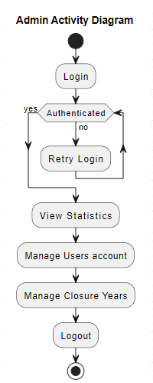

# 6. Sitemap

The website map drawn below provides the framework of the site by revealing its pages and directories. It contributes to the success of a website by both guiding users to the desired content and supporting search engine indexing. Webpages would include Home, About Us, Contact Us, Login, Create Account, Edit Account, Delete Account, Account Management, Admin Panel, Closing Day, Academy, Students, Marketing Management, Guest Invitation, Submitting and Viewing comments. Accessing contributions and Commenting contributions. On our web page, the highlight is links between pages and directories such as Home and About Us, Contact Us, Login, Create Account, and Account Management demonstrating a well desirable structure.

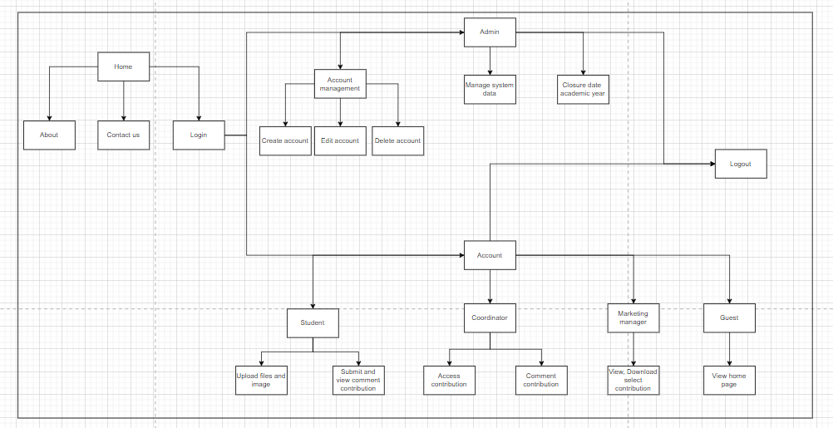

Admin sitemap

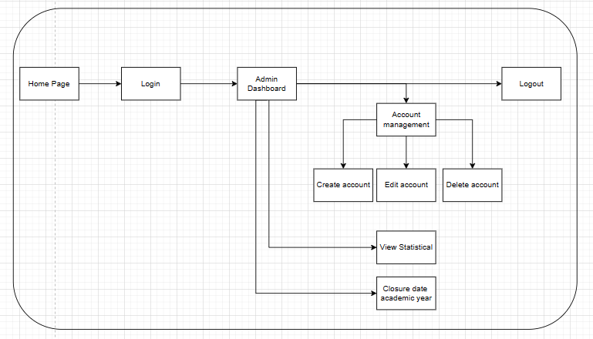

Student sitemap

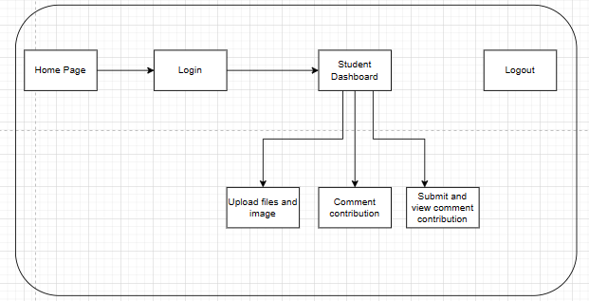

Marketing Coordinator

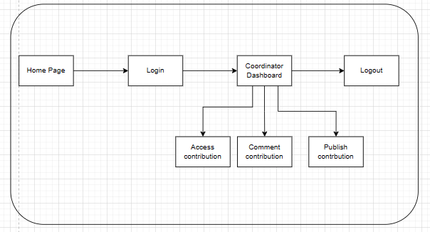

Marketing Manager

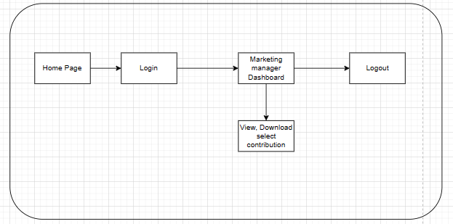

7. Sequence diagram

Student sequence diagram

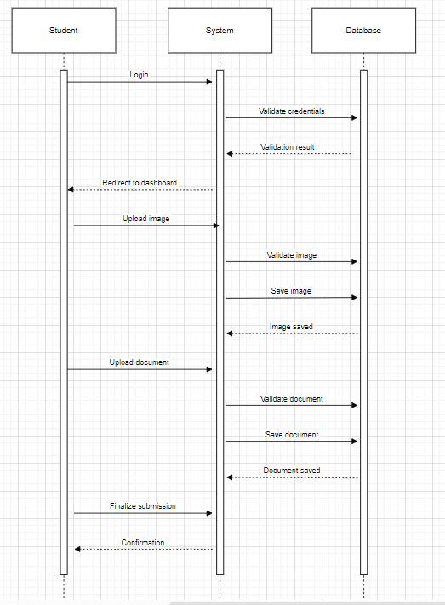

Marketing coordinator sequence diagram

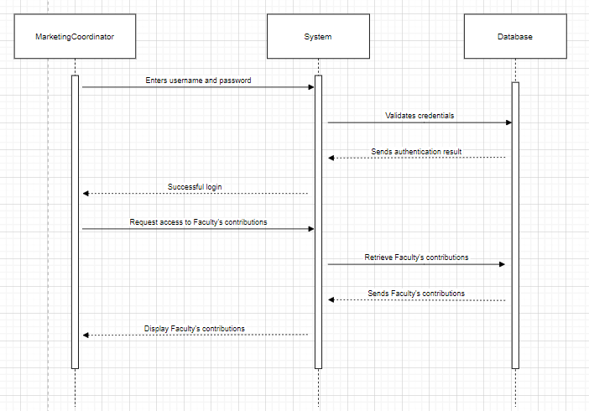

Marketing manager sequence diagram

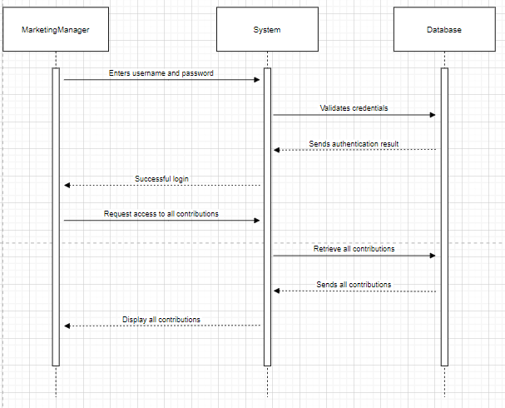

Admin sequence diagram

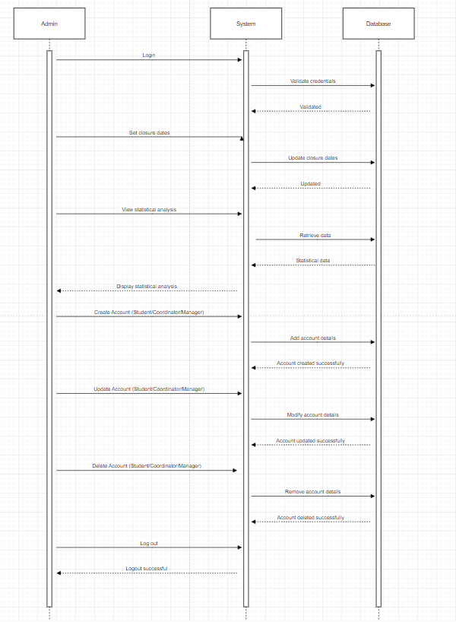

# 

# 9. Testing

|  |  |  |  |  |  |
| --- | --- | --- | --- | --- | --- |
| No. | Function | How to test | Expected test results | Actual test  results | Pass /  Fail |
|  | Login to system | Login by Admin account  Name: [admin@gmail.com](mailto:admin@gmail.com)  Pass: 1234567 | Login successful | Login successful | Pass |
|  | Logout to system | Logout by Admin account | Logout successful | Logout successful | Pass |
|  | Create student account | Input Information  Name: Test 1  Gmail: [Test1@gmail.com](mailto:Test@gmail.com)  Faculty: Design  Password: 1234567  Gender: Male  Image: Test1.jpg  City: Ho Chi Minh  Phone: 001  Role: Student | Create student account name Test 1 | Create student account name Test 1 successful | Pass |
|  | Create student account | Input Information  Name: Test 2  Gmail: [Test2@gmail.com](mailto:Test@gmail.com)  Faculty: Computing  Password: 1234567  Gender: Male  Image: Test2.jpg  City: Ho Chi Minh  Phone: 002  Role: Student | Create student account name Test 2 | Create student account name Test 2 successful | Pass |
|  | Create student account | Input Information  Name: Test 3  Gmail: [Test3@gmail.com](mailto:Test@gmail.com)  Faculty: Business  Password: 1234567  Gender: Female  Image : Test3.jpg  City : Ho Chi Minh  Phone : 001  Role : Student | Create student account name Test 3 | Create student account name Test 3 successful | Pass |
|  | Re-create an existing student account | Input Information  Name : Test 1  Gmail: [Test1@gmail.com](mailto:Test@gmail.com)  Faculty : Business  Password: 1234567  Gender : Female  Image : Test1.jpg  City : Ho Chi Minh  Phone : 001  Role : Student | Notification that the account already exists | Notification that the account already exists | Pass |
|  | Create student account | Input Information  Name : Test 4  Faculty : Business  Password: 1234567  Gender : Female  Image : Test4.jpg  City : Ho Chi Minh  Phone : 004  Role : Student | Do not add an account without enough information | Notice that information is missing and must be supplemented if you want to add an account | Pass |
|  | Create marketing manager account | Input Information  Name: Marketing Manager 1  Faculty: Business  Password: 1234567  Gender: Female  Image: manager1.jpg  City: Ho Chi Minh  Phone: 12345  Role: Manager | Create marketing manager account name Marketing Manager 1 | Create marketing manager account name Marketing Manager 1 successful | Pass |
|  | Create marketing manager account | Input Information  Name: Marketing Manager 2  Faculty: Business  Password: 1234567  Gender: Female  Image: manager2.jpg  City: Ho Chi Minh  Phone: 12345  Role: Manager | Phone number information is duplicated and must be re-entered | Re-entered phone number information successfully | Pass |
|  | Create Coordinator account | Input Information  Name: Coordinator 1  Faculty: Business  Password: 1234567  Gender: Female  Image: coordinator1.jpg  City: Ho Chi Minh  Phone: 0008  Role: coordinator | Create coordinator account name Coordinator 1 | Create coordinator account name Coordinator 1 successful | Pass |
|  | Edit account student | Edit account student  Name: Test 1 => Test 1 new | Update account student | Update account student successful | Pass |
|  | Edit account student | Edit account student  Name: Test 1 new  Gmail: Test1gmail.com  => test@gmail.com  Account is duplicated: Name test  Gmail: test@gmail.com | Edit an existing student gmail account that overlaps with another account | Notice of duplicate gmail and request to re-enter | Pass |
|  | Update image student | Update account student  Name: Test 1 new | Update new image | Update new image successful | Pass |
|  | Update image marketing manager | Update account marketing manager  Name: Marketing Manager 1 | Update new image | Update new image successful | Pass |
|  | Update image coordinator | Update account coordinator  Name: Coordinator | Update new image | Update new image successful | Pass |
|  | Delete account student | Delete account student  Name: Test 1 new | Delete account student | Delete account studen007 successful | Pass |
|  | Delete marketing manager account | Delete account Marketing Manager  Name: Marketing Manager 1 | Delete account marketing manager | Delete account marketing manager successful | Pass |
|  | Delete coordinator account | Delete account coordinator  Name: Coordinator | Delete account coordinator | Delete account coordinator successful | Pass |
|  | Check Terms and Conditions before submit contribution | Terms and Conditions: You must agree to the user terms | If not check the box before submit will pop up alert | Check the box before submit contribution and contribution submit successful | Pass |
|  | Create Academy | Input information Academy  Name: test academy  Description: test academy Start date: 7/4/2024  End date: 10/4/2024 | Create Academy | Create Academy successful | Pass |
|  | Edit name Academy | Edit information Academy  Id: 03  Name: test academe  => test academe new  Description: test academe Start date: 7/4/2024  End date: 10/4/2024 | Edit name Academy | Edit Name Academy successful | Pass |
|  | Delete Academy | Delete information Academy  Id: 03  Name: test academy new  Description: test academy Start date: 7/4/2024  End date: 10/4/2024 | Delete Academy | Delete Academy successful | Pass |
|  | Login account student | Login account student name Test 1 | Login successful | Login successful | Pass |
|  | Check academy | Academy is still valid | Blogs can be added | Successful | Pass |
|  | Check academy | Academy is no longer valid | Cannot add blog | Successful | Pass |
|  | Submit contribution | Input information in submission form  Title: Blog test1  Content: Blog test1  Upload Background Image:  Test1.jpg  Upload File: testaddblog.docx  Click box: terms and conditions | Submit contribution successful | Submit contribution successful | Pass |
|  | Submit contribution | Input information in submission form  Title: Blog test2  Content: Blog test2  Upload Background Image:  Test2.jpg  Upload File: testaddblog.docx  Click box: terms and conditions | Submit contribution successful | Submit contribution successful | Pass |
|  | Logout account student | Logout account student name Test 1 | Logout successful | Logout successful | Pass |
|  | Login account coordinator | Login account coordinator name Coordinator 1 | Login successful | Login successful | Pass |
|  | Comments in student contribution | comment on contribution name: Blog test 1 | Comment contribution successful | Comment contribution successful | Pass |
|  | Logout coordinator account | Logout account coordinator name Coordinator 1 | Logout successful | Logout successful | Pass |
|  | Login marketing manager account | Login account marketing manager name Marketing Manager 1 | Login successful | Login successful | Pass |
|  | Create guest account | In marketing manager account create guest account  Input gmail, name, password, phonenumber, image, city | Create guest account | Create guest account successful | Pass |
|  | Edit guest account | In marketing manager account create guest account  Guest account information can be edited | Edit guest account | Edit guest account successful | Pass |
|  | Delete guest account | In marketing manager account create guest account  Guest account information can be deleted | Delete guest account | Delete guest account successful | Pass |
|  | Download contribution | Download published contribution | Download  successful | Download contribution successful | Pass |
|  | Logout account marketing manager | Logout account marketing manager name Marketing Manager 1 | Logout successful | Logout successful | Pass |

1. Agile Method: Sprint Planning, Sprint Backlogs, Schedule, Daily Meetings, Sprint Review & Retrospective Meetings, Burndown Charts
   1. Vai trò trong sprint

**Scrum Master:**

1. Đảm bảo rằng quy trình Scrum được tuân thủ và thực hiện đúng cách trong suốt quá trình phát triển.
2. Tổ chức và chủ trì các cuộc họp hàng ngày (daily stand-ups), cuộc họp lập kế hoạch sprint (sprint planning), cuộc họp đánh giá sprint (sprint review), và cuộc họp tổng kết sprint (sprint retrospective).
3. Giúp loại bỏ các rào cản và vấn đề mà nhóm phải đối mặt, đảm bảo sự tiến triển liên tục và hiệu quả.
4. Hỗ trợ nhóm trong việc giải quyết các vấn đề và xử lý các rủi ro.
5. Đảm bảo rằng sản phẩm đáp ứng được yêu cầu của khách hàng và đạt được chất lượng mong đợi.

**Product Owner**

1. Xác định và ưu tiên các yêu cầu của sản phẩm trong product backlog dựa trên giá trị kinh doanh và yêu cầu của khách hàng.
2. Lập kế hoạch và quản lý product backlog, bao gồm việc phân tích yêu cầu, xác định ưu tiên, và chuẩn bị user stories cho nhóm phát triển.
3. Tham gia vào các cuộc họp lập kế hoạch sprint (sprint planning) để chỉ rõ yêu cầu và mục tiêu của sprint.
4. Cung cấp phản hồi và hướng dẫn cho nhóm phát triển trong suốt quá trình phát triển sản phẩm.
5. Đảm bảo rằng sản phẩm được phát triển đáp ứng được nhu cầu và mong muốn của khách hàng, và đạt được mục tiêu kinh doanh.

**Development Team:**

1. Tham gia vào việc phát triển và triển khai các tính năng theo yêu cầu của product backlog trong mỗi sprint.
2. Hợp tác chặt chẽ với Scrum Master và Product Owner để hiểu rõ yêu cầu và ưu tiên công việc.
3. Tích cực tham gia các cuộc họp hàng ngày để báo cáo tiến độ và thảo luận về các thách thức.
4. Thực hiện kiểm tra và đánh giá code của nhau để đảm bảo chất lượng mã nguồn.
5. Chịu trách nhiệm về việc hoàn thành các công việc được giao trong mỗi sprint, đảm bảo đáp ứng kỳ vọng về chất lượng và thời gian.

**Tester:**

1. Phát triển kế hoạch kiểm thử và chuẩn bị các tài liệu kiểm thử cần thiết.
2. Tham gia vào việc xác định các yêu cầu kiểm thử từ product backlog và lập kế hoạch kiểm thử cho từng sprint.
3. Thực hiện các bài kiểm thử (test cases) để kiểm tra tính năng và chất lượng của sản phẩm.
4. Ghi lại và báo cáo các lỗi (bugs) hoặc vấn đề về chất lượng cho nhóm phát triển để sửa chữa.
5. Hỗ trợ nhóm trong việc tự động hóa kiểm thử và triển khai các công cụ kiểm thử tự động để tối ưu hóa quy trình kiểm thử.
   1. Sprint Planning

|  |  |  |  |
| --- | --- | --- | --- |
| **Task** | **Role** | **Duration (hours)** | **Timescale** |
| Sprint Planning - Sprint 1 | Scrum Master | 1-2 | Week 1 |
| Validate project direction with stakeholders. Ensure ERD and Use Case Diagram reflect stakeholder needs. Enhance UI design for usability and branding. | Product Owner, Development Team | 1-2 | Week 1 |
| Sprint Planning - Sprint 2 | Scrum Master | 1-2 | Week 2 |
| Develop a user-friendly login interface for admins and users. Create an intuitive information management interface for admins. | Product Owner, Development Team | 1-2 | Week 2 |
| Sprint Planning - Sprint 3 | Scrum Master | 1-2 | Week 3 |
| Design site map and activity diagram. Implement article submission and notification system. Introduce student agreement page for file uploads. | Product Owner, Development Team | 1-2 | Week 3 |
| Sprint Planning - Sprint 4 | Scrum Master | 1-2 | Week 4 |
| Implement System Data Management and Marketing Coordination. Develop a statistical analysis dashboard for faculty contributions. | Product Owner, Development Team | 1-2 | Week 4 |
| Sprint Planning - Sprint 5 | Scrum Master | 1-2 | Week 5 |
| Develop a dashboard for marketing manager to access magazine contributions. Optimize website for accessibility and responsive design on all devices. | Product Owner, Development Team | 1-2 | Week 5 |

* 1. Product Backlogs

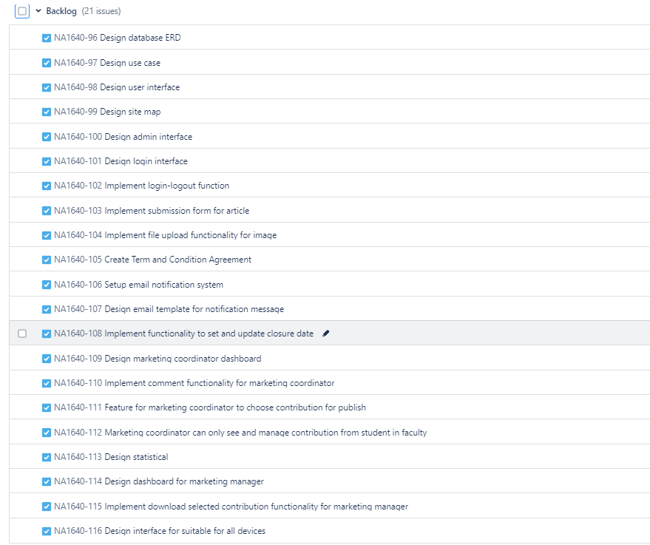

* 1. Sprint backlog

Sprint 1

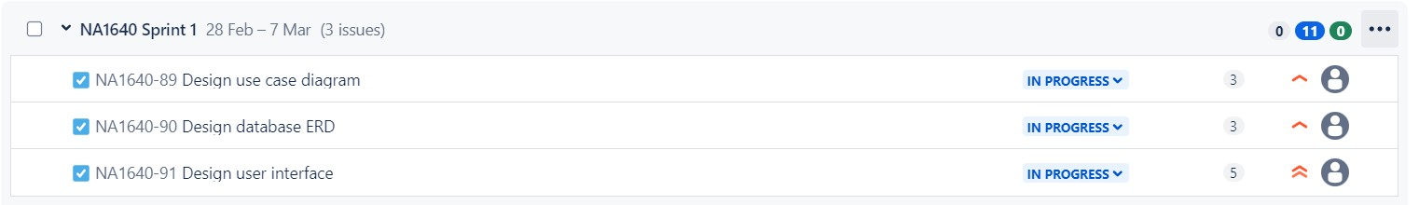

Sprint 2

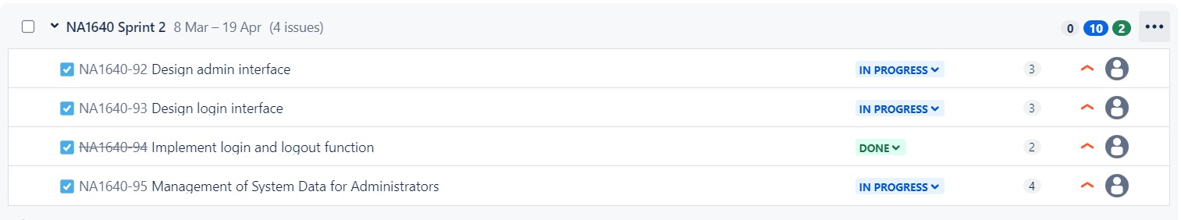

Sprint 3

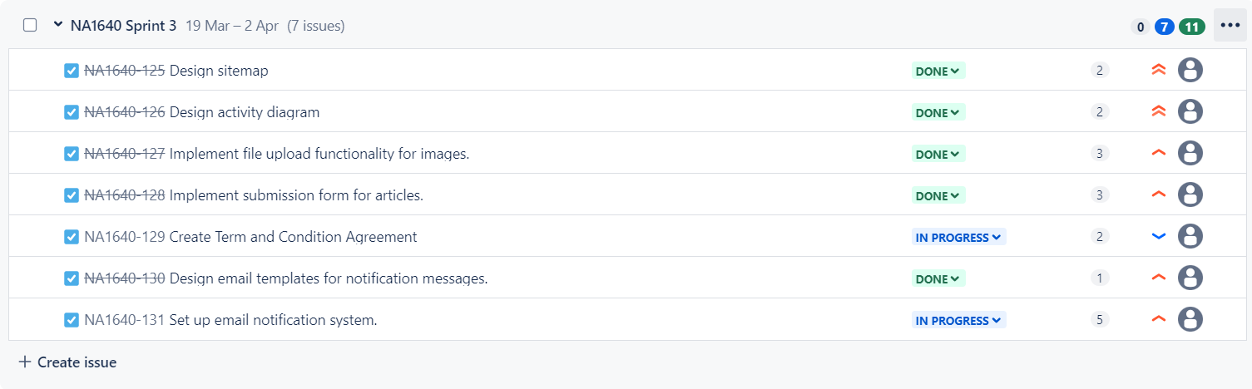

Sprint 4

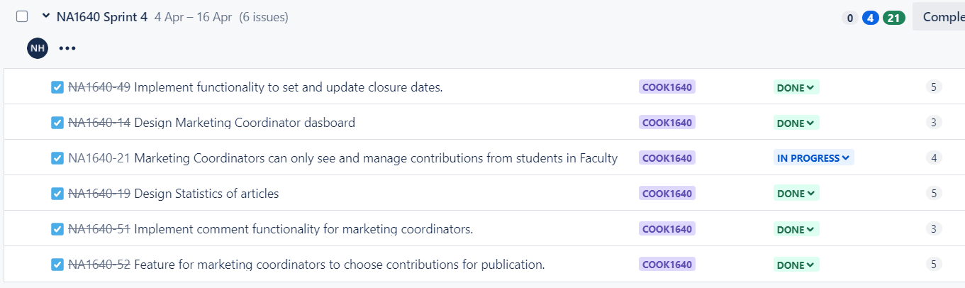

Sprint 5

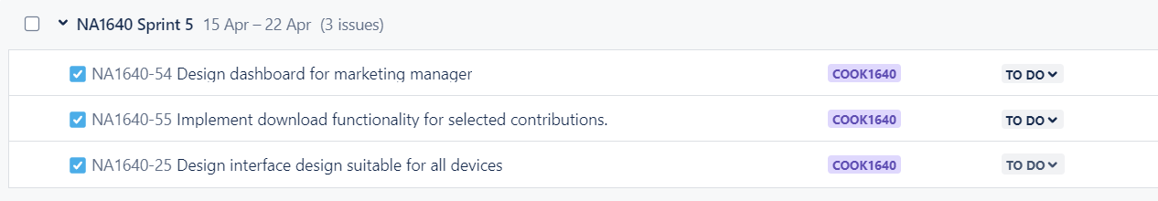

* 1. Sprint Retrospective Meetings

Meeting Srint 1

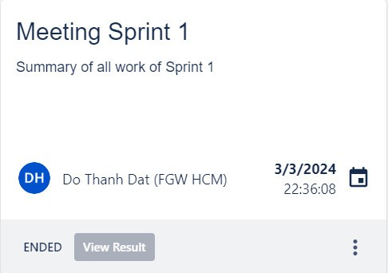

Meeting Sprint 2

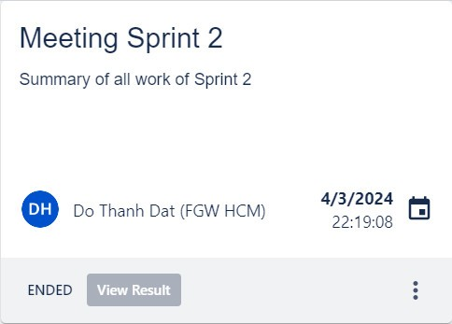

Meeting Sprint 3

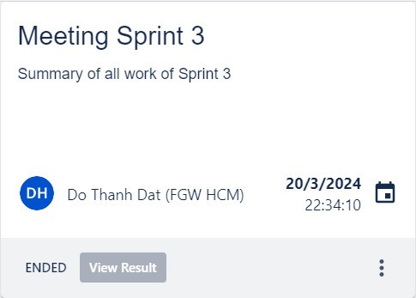

Meeting Sprint 4

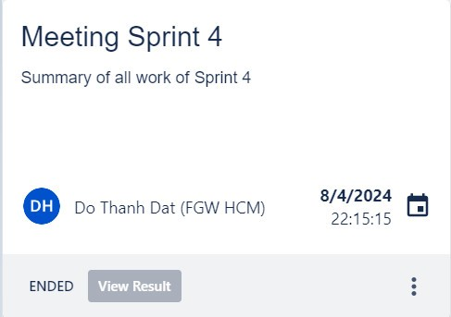

* 1. Daily stand up

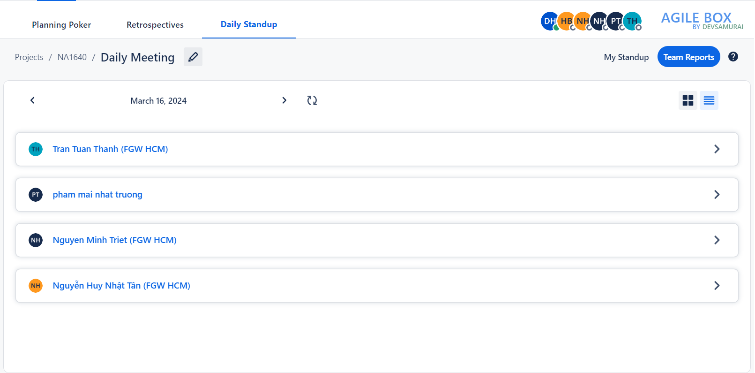

* 1. Sprint Review

**Sprint review – Sprint 1**

Our three-pronged sprint aim was:   
Verify that the project's course meets the needs and expectations of the stakeholders.   
Verify that the requirements listed in the ERD and Use Case Diagram accurately reflect the needs of the stakeholders.   
To improve the UI design's usability, intuitiveness, and branding alignment, get user feedback.  
Feedback Gathering  
Validation of Requirements  
User Interface Validation  
Early Issue Identification

|  |  |
| --- | --- |
| Demo instructions | Feedback |
| Requirements Team: Validate that the project's direction aligns with stakeholders' expectations and requirements, showcasing alignment with ERD and Use Case Diagram. | Suggest conduct a thorough review with a wider group of stakeholders to ensure we capture all necessary needs accurately |
| Development Team: Confirm the accuracy of requirements captured in the ERD and Use Case Diagram, demonstrating how the system's behavior and data model meet stakeholders' needs. | Stakeholder desires increased accuracy. |
| UI/UX Team: Gather feedback on the UI design, showcasing visualizations of the system's look and feel and soliciting feedback on usability, intuitiveness, and branding alignment**.** | Gather direct feedback from end-users. This will allow us to identify any potential usability issues and make refinements to further improve the user experience. |

**Complete and deliver to the client:**  
Having illustrations and an overview of the features that consumers requested demonstrates the team's professionalism in promoting job progress.

**Sprint review – Sprint 2**

**Sprint goal Top of Form**

In Sprint 2, our goal was to deploy processes identified in Sprint 1 and prioritize two key tasks:

* Creation of a user-friendly login interface for administrators and users.
* Development of an intuitive information management interface tailored for administrators.

|  |  |
| --- | --- |
| Demo instructions | Feedback |
| Login Interface: Demonstrate the user-friendly login interface designed for seamless system access by both administrators and regular users. | Meets usability standards for both administrators and users. The interface is intuitive, making it easy for users to access the system seamlessly. However, Stakeholder suggest considering additional user authentication options such as multi-factor authentication to enhance security further. |
| Information Management Interface: Showcase the intuitive interface providing administrators with effective tools for overseeing and managing critical system data. | Recommend incorporating customizable reporting features to provide administrators with greater insights into system usage and performance. |

**Complete and bring to Client**

We have successfully delivered the interface exactly as requested by our customers, seamlessly integrating essential features like login, logout, and an intuitive admin management interface. This achievement reflects our commitment to meeting and exceeding customer expectations, ensuring a smooth and user-friendly experience for all users.

**Sprint review – Sprint 3**

**Sprint goal** Top of Form

We will come up with the next design of the site, namely the site map and activity diagram. Focus to implement function that help user can submission article also create a notification system for each submission contribution to Marketing coordinator. At last, will have a page for student agreement when students upload file.

* Develop the site map and activity diagram for the next design iteration.
* Implement features to facilitate user article submissions.
* Create a notification system to alert the Marketing Coordinator of each submission contribution.
* Introduce a page for student agreement during file uploads.

|  |  |
| --- | --- |
| Demo instructions | Feedback |
| Design Team: Showcase the finalized site map and activity diagram for the upcoming design iteration. | Adjusted and corrected symbol errors for diagrams and some logic in the system. |
| Development Team: Demonstrate the functionality allowing users to submit articles and the notification system implemented for the Marketing Coordinator. | Some submission formats are missing and need to be added. |
| UI/UX Team: Present the student agreement page design and its integration into the file upload process. | It is not possible to edit the conditions that need to improve this feature |

**Complete and bring to Client**

We are pleased to announce the triumphant conclusion of Sprint 3, during which we not only produced thorough diagrams to improve the readability of the website but also skillfully integrated extra features. These accomplishments demonstrate our dedication to timely and high-quality project delivery.

**Sprint review – Sprint 4**

**Sprint goal**

Our goal for Sprint 4 was to improve the platform by implementing System Data Management, Marketing Coordination, Statistical Analysis:

|  |  |
| --- | --- |
| Demo instructions | Feedback |
| **System Data Management**: The team will demonstrate how closure dates for academic years can be managed and updated within the system. | Clarification may be needed on how closure dates are managed within the system. Ensure that it's intuitive and easy to understand for users.  Consider adding features like notifications or reminders for upcoming closure dates to improve user experience |
| **Marketing Coordination**: The team will showcase the designed and developed features that enable marketing coordinators to interact with students, manage contributions, comment, approve or reject publications. | Evaluate if the features provided are comprehensive enough for marketing coordinators to efficiently manage contributions and publications. |
| **Statistical Analysis**:  Demo the statistical analysis dashboard created to view contributions per faculty. The team will present the dashboard interface and provide insights into the data visualization and analysis capabilities it offers. | Ensure that the statistical analysis dashboard provides meaningful insights and is user-friendly for faculty members. |

**Complete and bring to Client**

Comprehensive System Data Management module enabling the efficient management and updating of closure dates for academic years within the system.

Enhanced Marketing Coordination features empowering marketing coordinators to seamlessly interact with students, manage contributions, and efficiently handle publication-related tasks such as commenting, approving, or rejecting submissions.

Show a statistics table so administrators can view specific statistics

**Sprint review- Sprint 5   
Sprint goal**

For Sprint 5, the team will focus on developing a dashboard that allows the marketing manager to seamlessly access and download magazine contributions. Additionally, the sprint will prioritize optimizing the website to ensure it is accessible and user-friendly on all types of devices, along with implementing a responsive interface design that adapts to different screen sizes. This sprint aims to enhance the overall user experience and provide essential features for both managers and end-users.

|  |  |
| --- | --- |
| Demo instructions | Feedback |
| Dashboard Implementation | Gather feedback on the clarity of the dashboard interface and the usefulness of the displayed information. |
| Website Optimization | Improve user-friendliness along with access speed, |
| Download Functionality | Confirm that the download functionality for magazine contributions is straightforward and user-friendly. |
| Interface Design | Difficult to use does not show all publication on the page in each user. |

9.7. Burndown chart

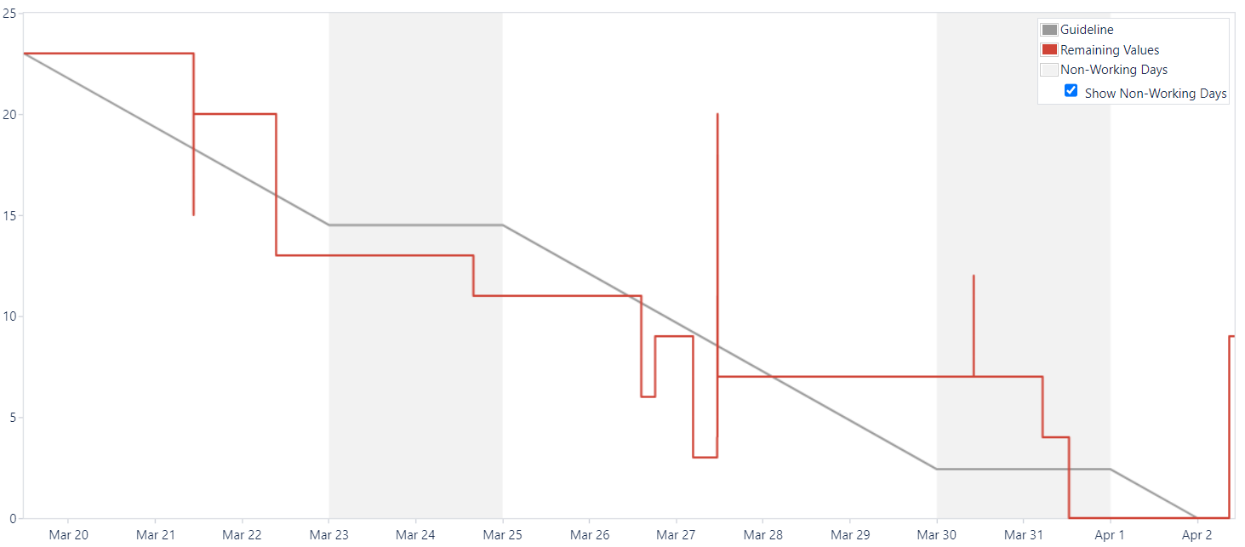

9.8. Schedule

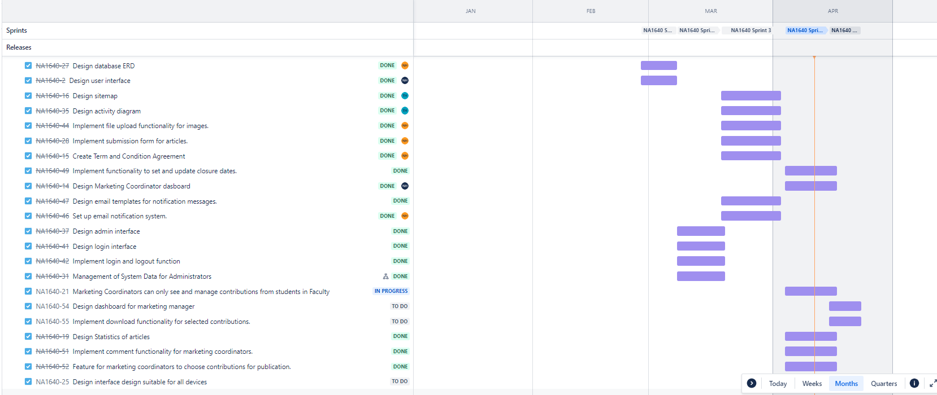

# **10. Wireframe**

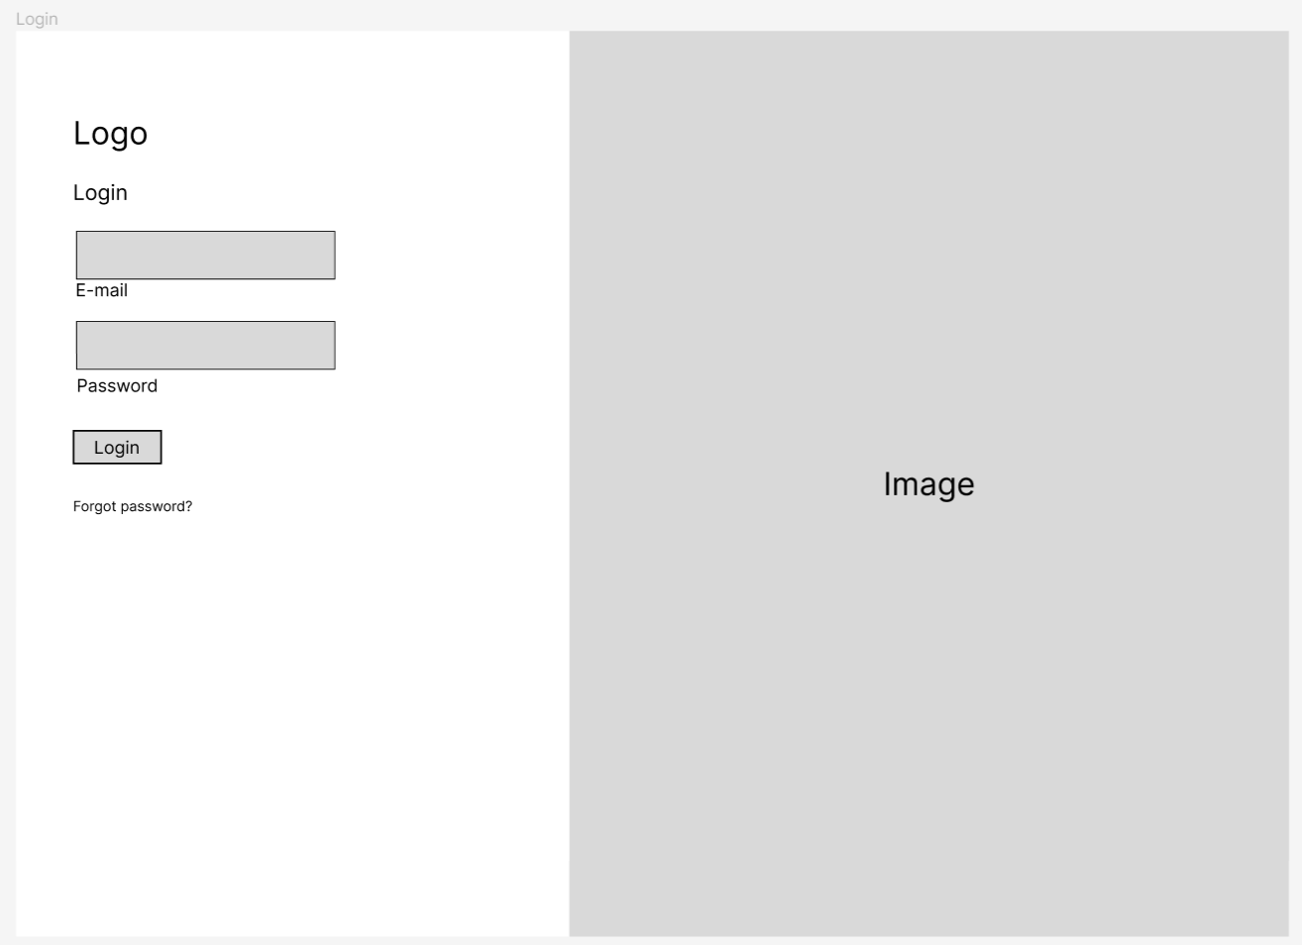

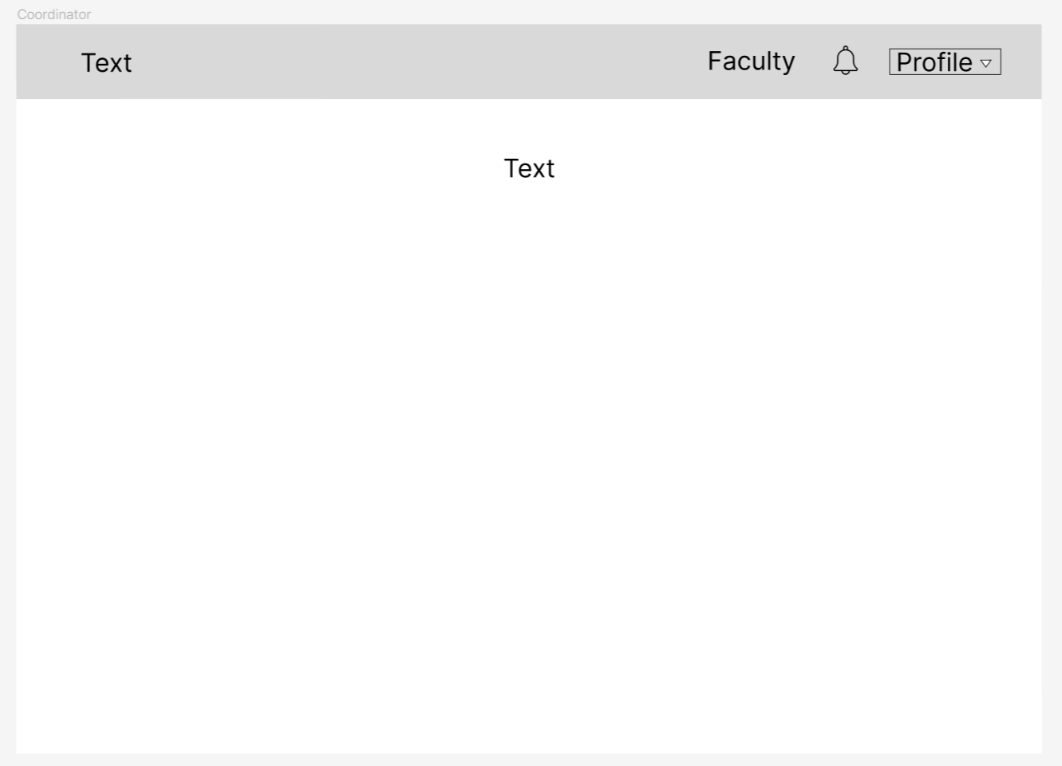

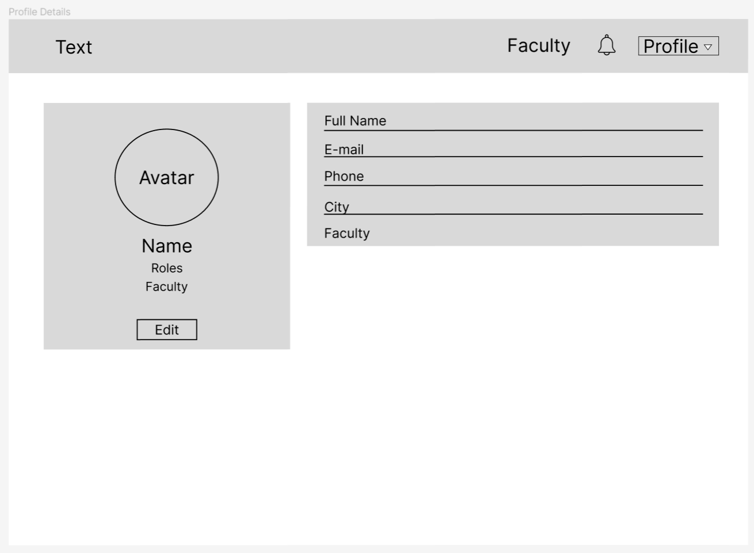

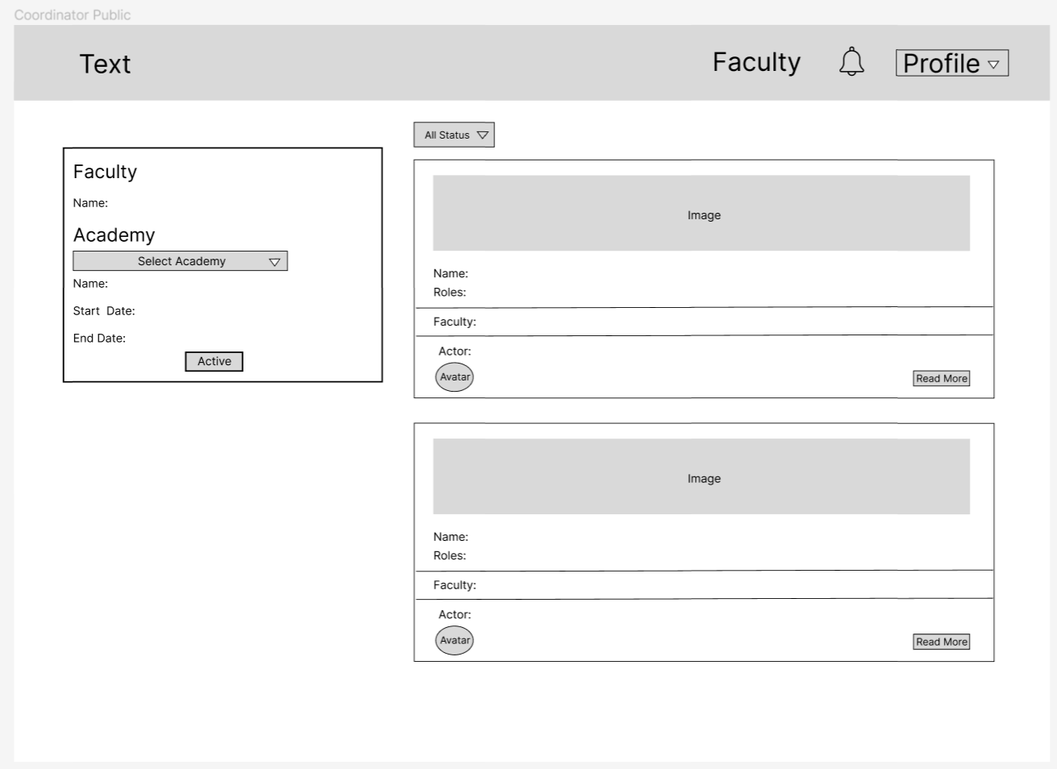

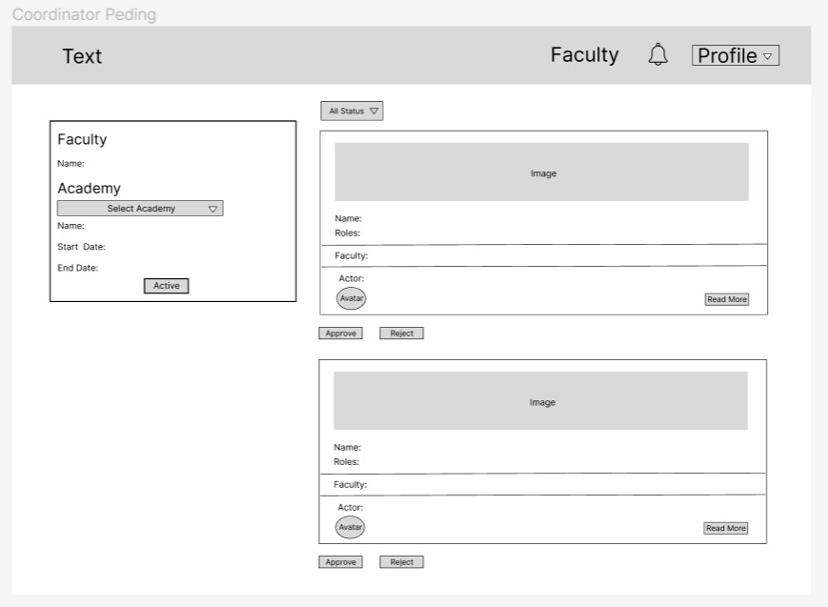

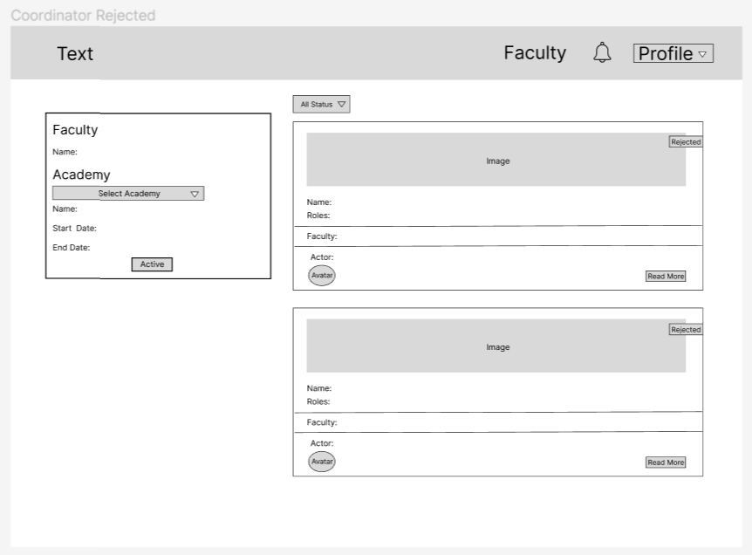

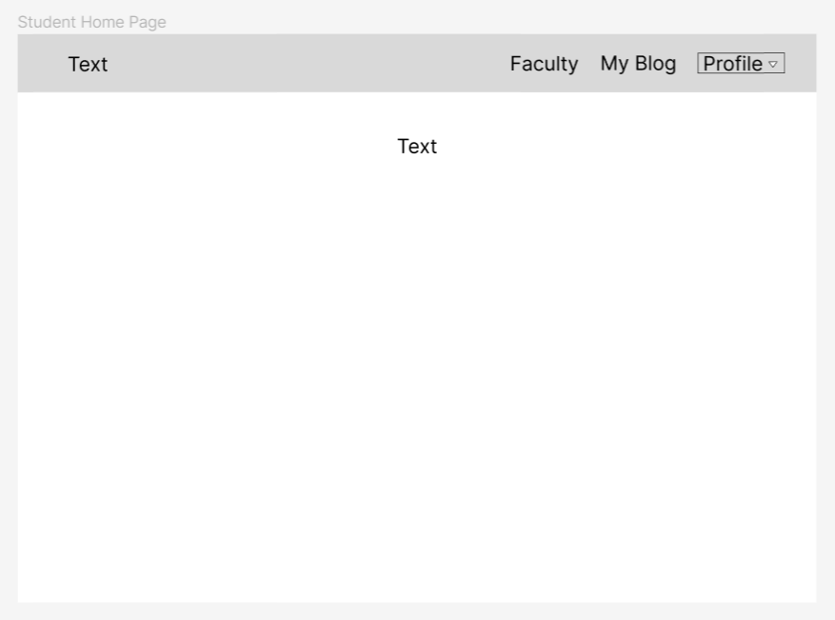

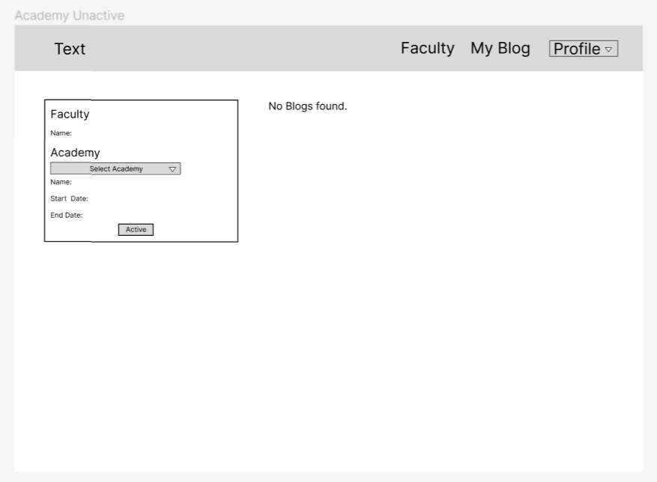

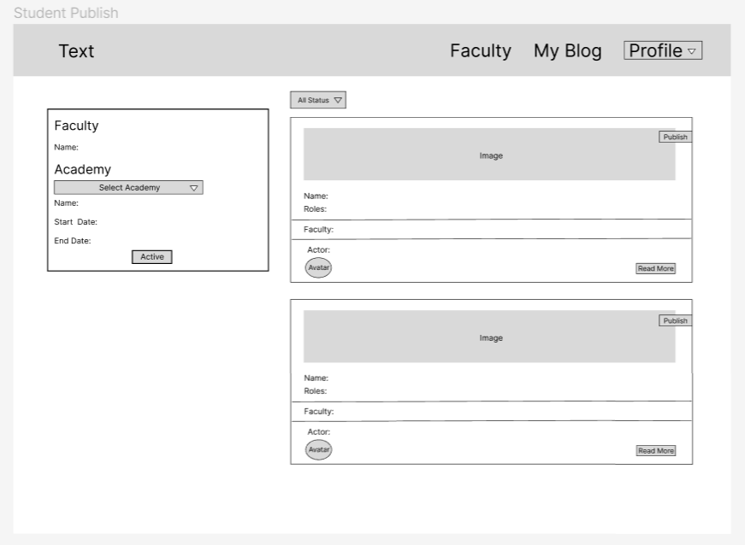

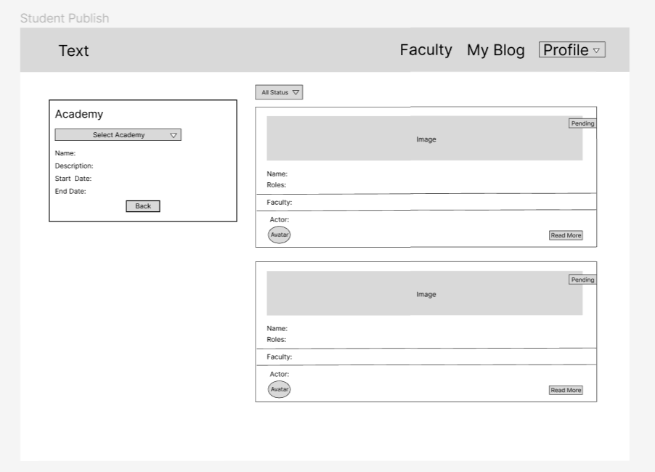

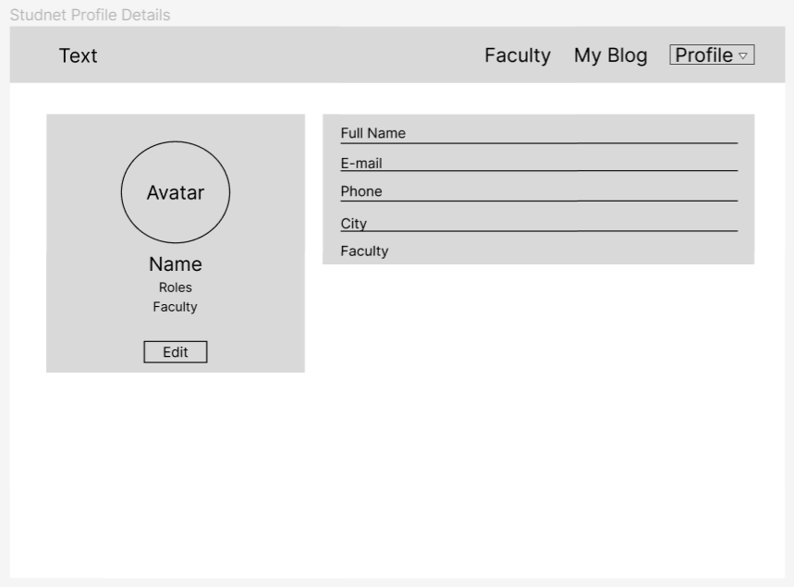

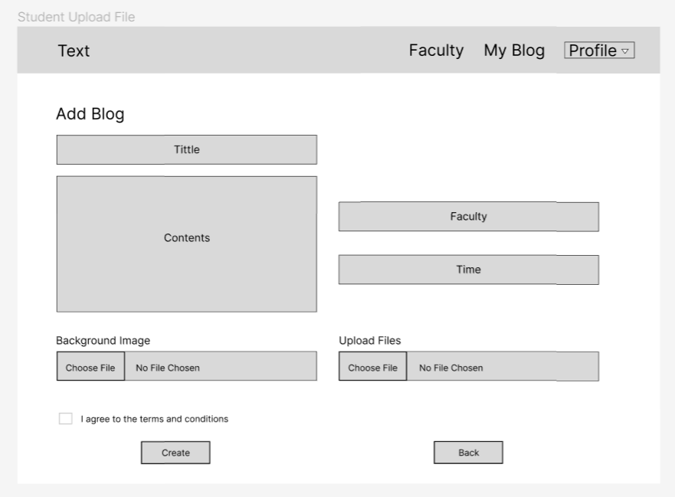

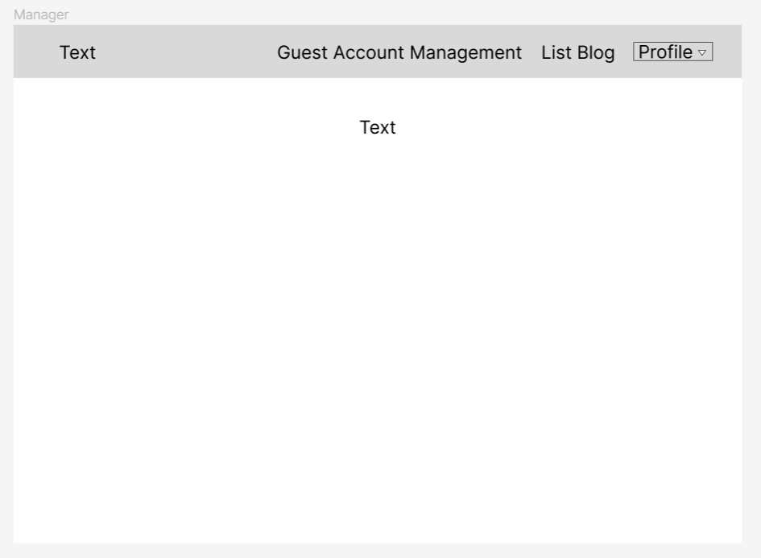

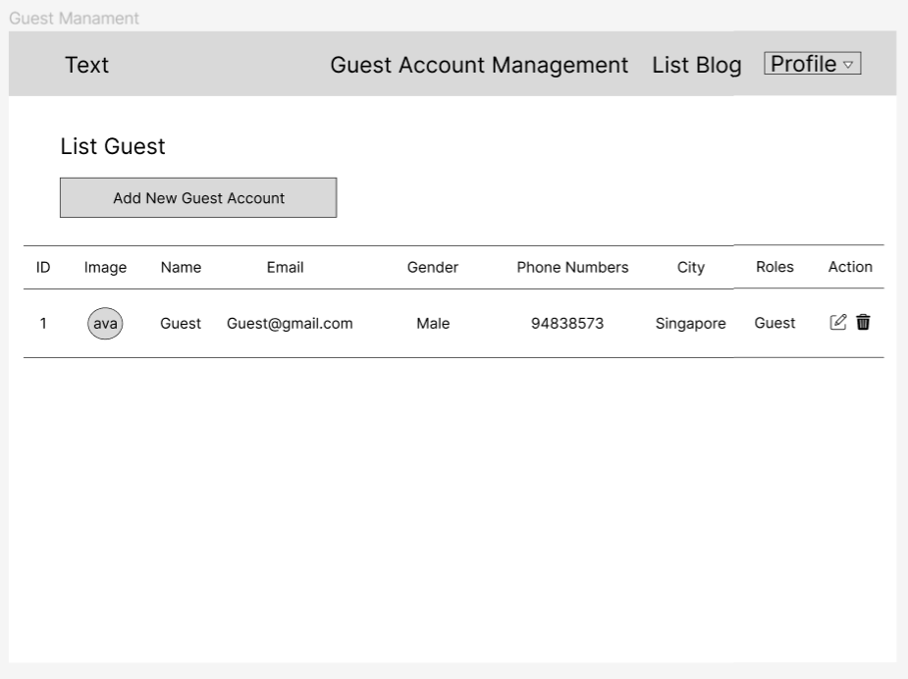

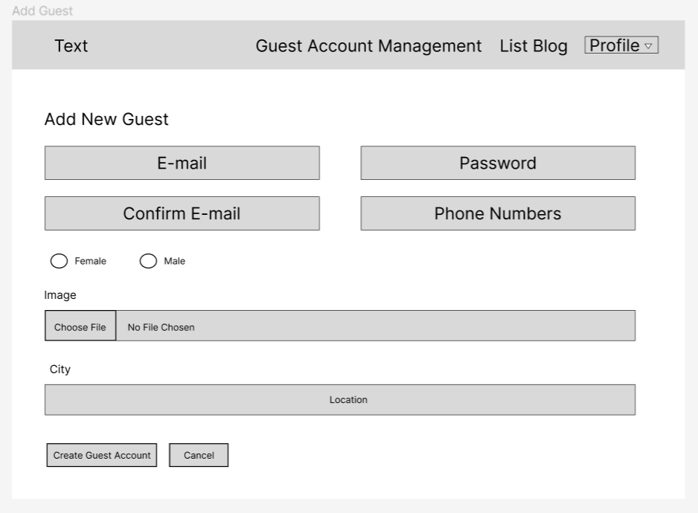

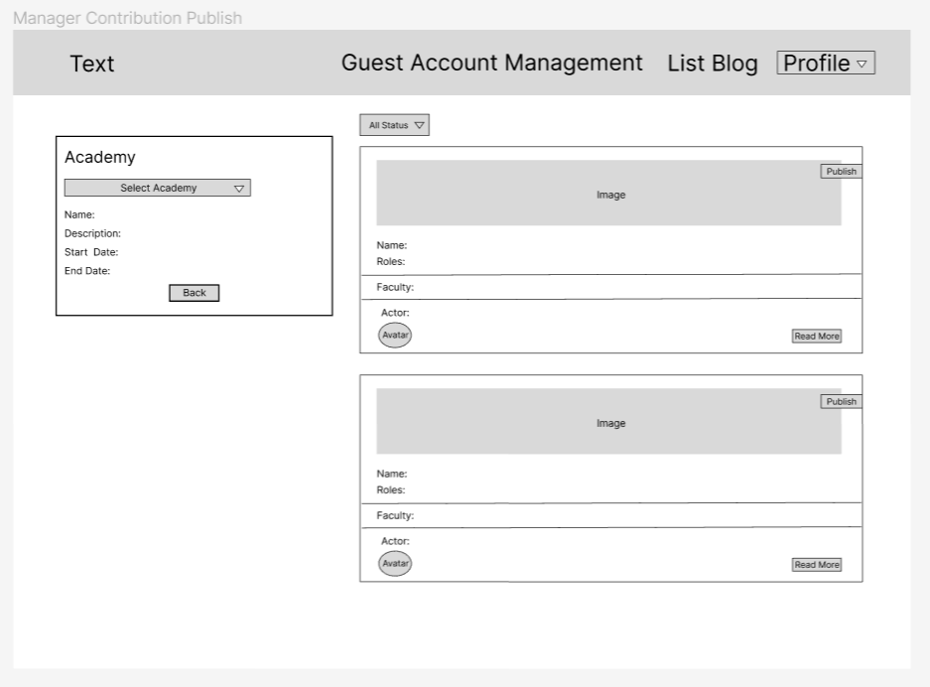

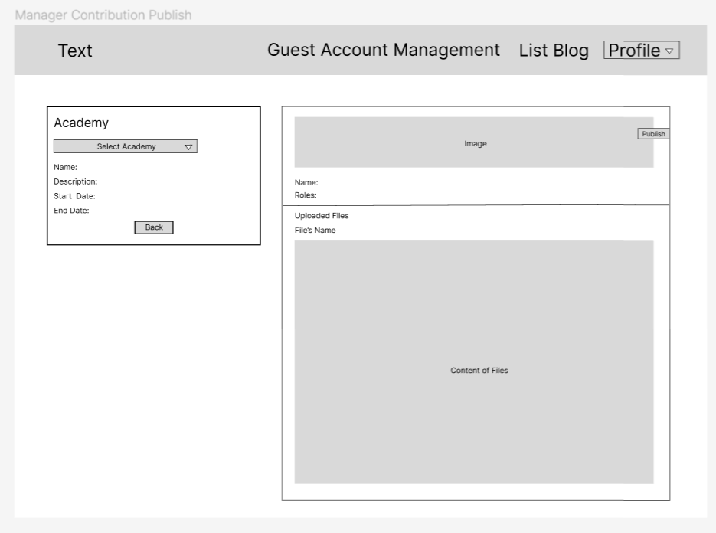

# 

# 11. Product screenshots of your actual application and its functions

Admin home page

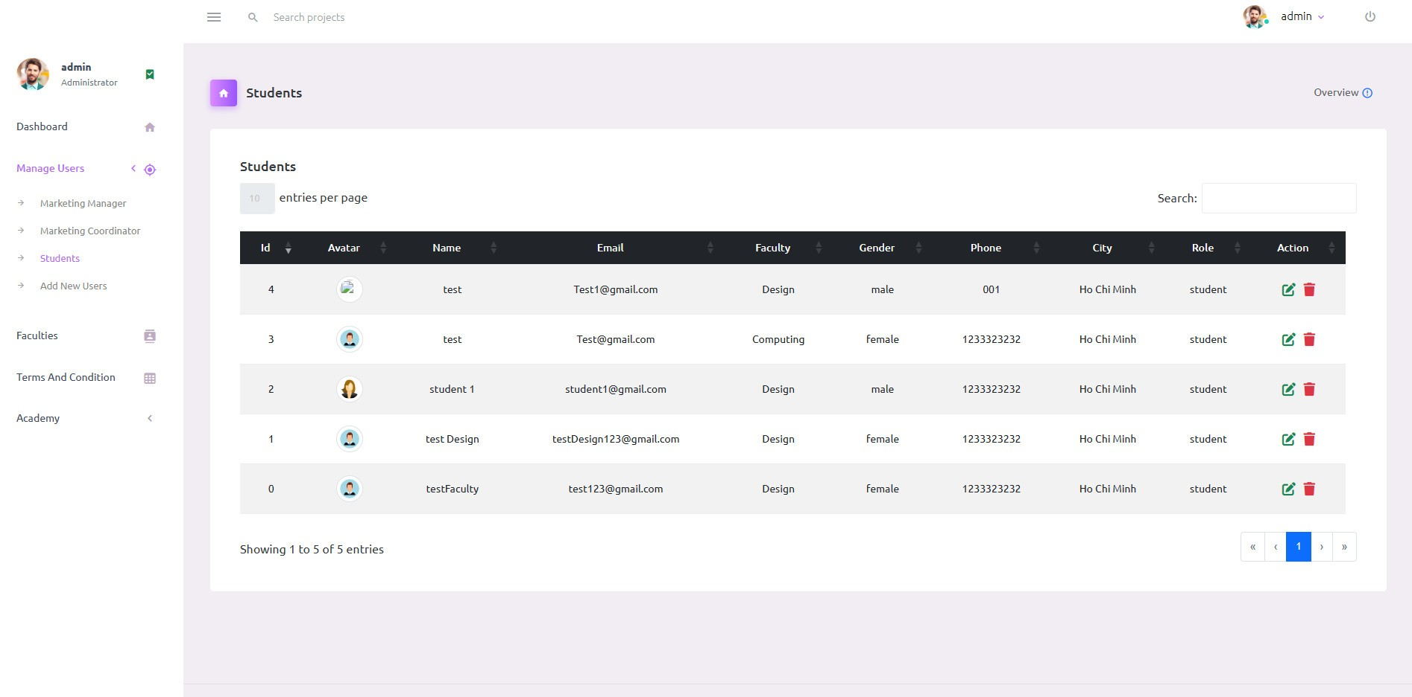

Admin add user account page

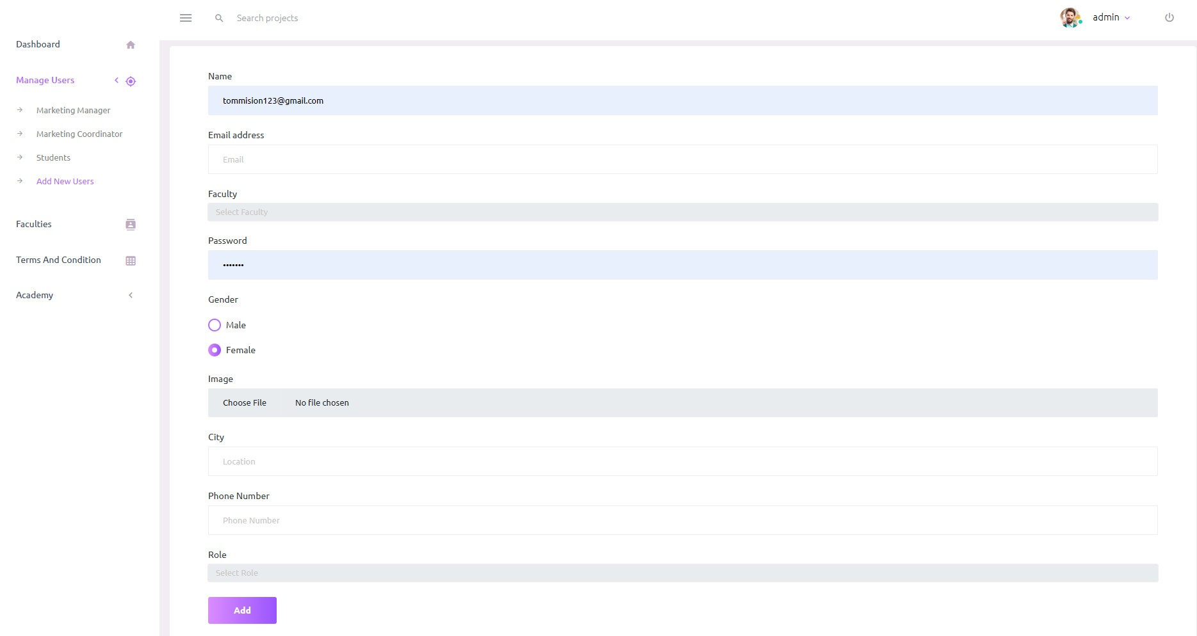

Admin manage the faculty page

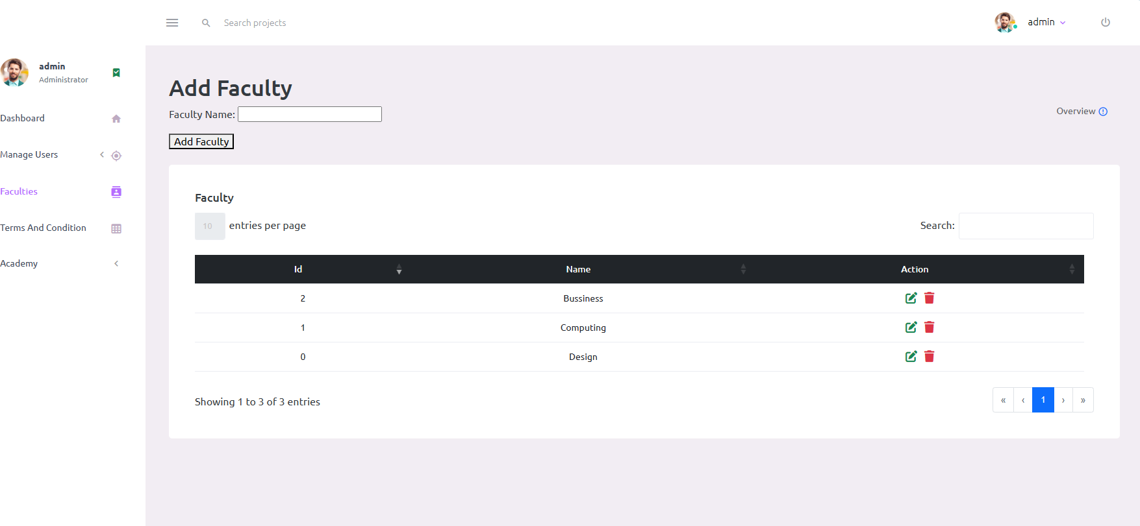

Admin manage the Academy year

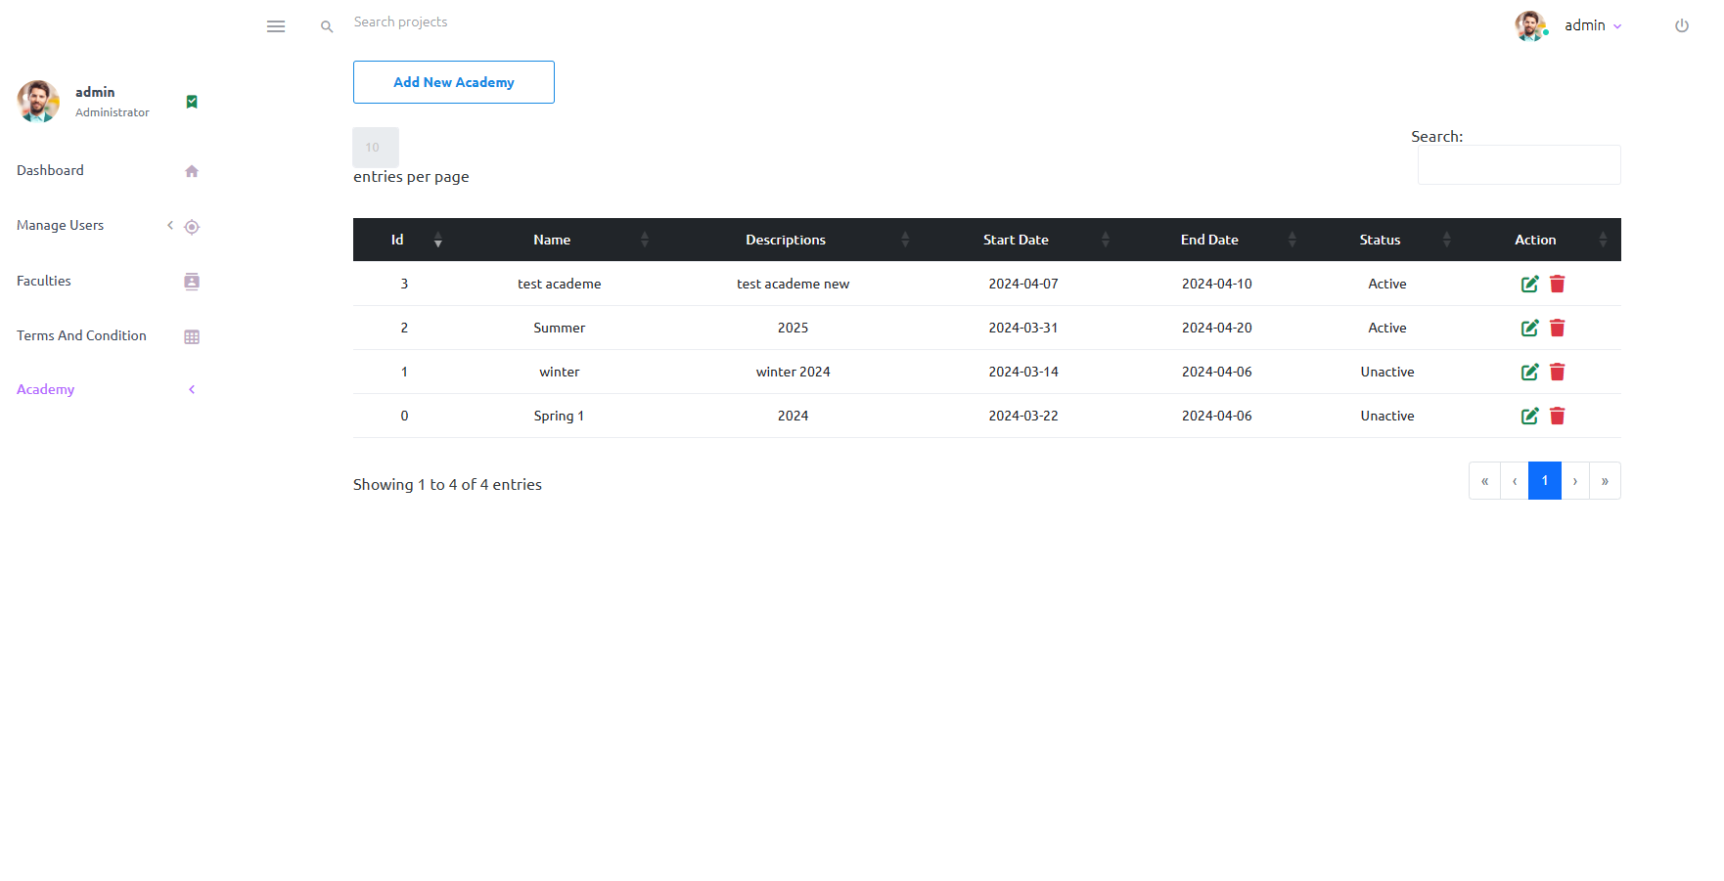

Marketing coordinator home page

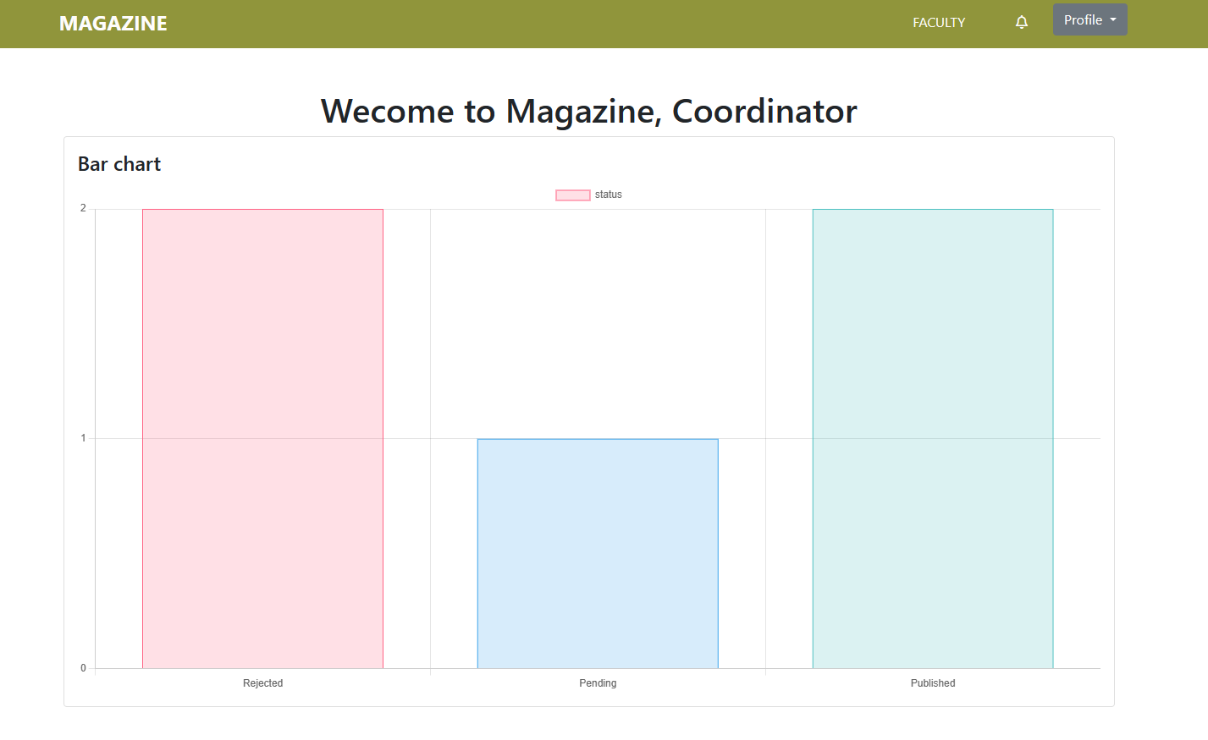

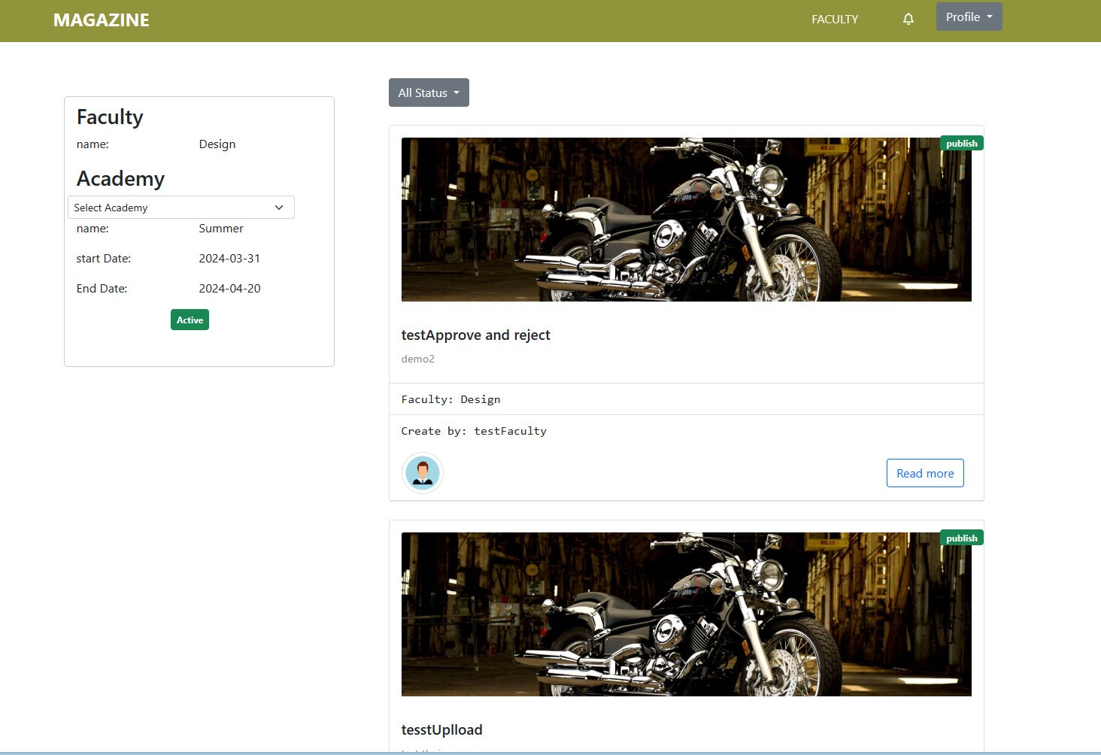

Contribution detail page

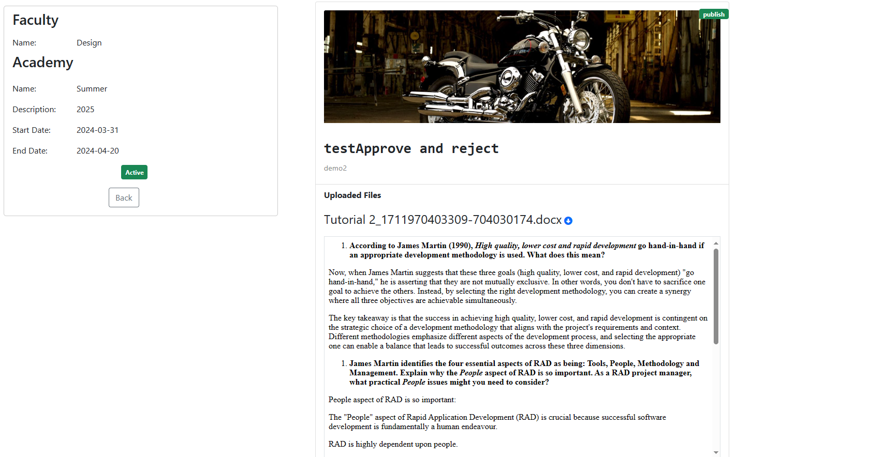

Marketing coordinator oversee the contribution of student

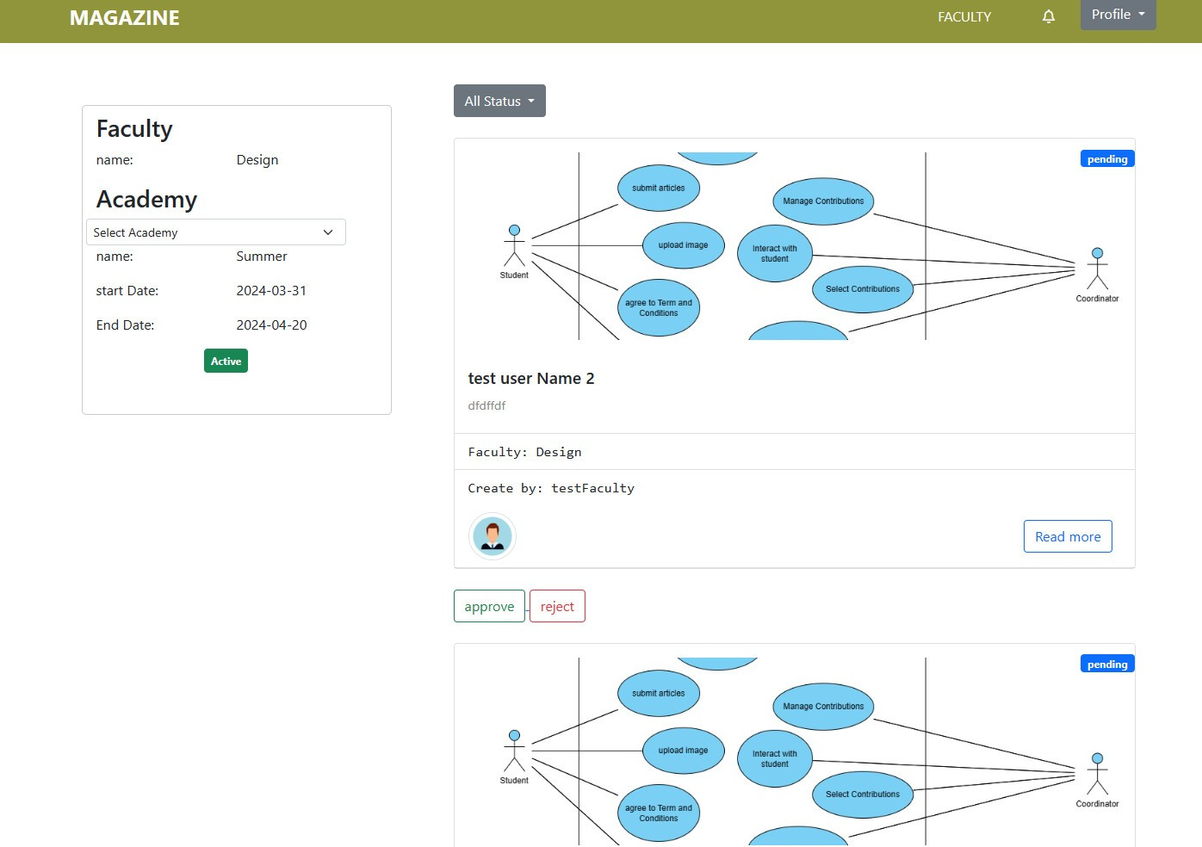

Marketing profile page

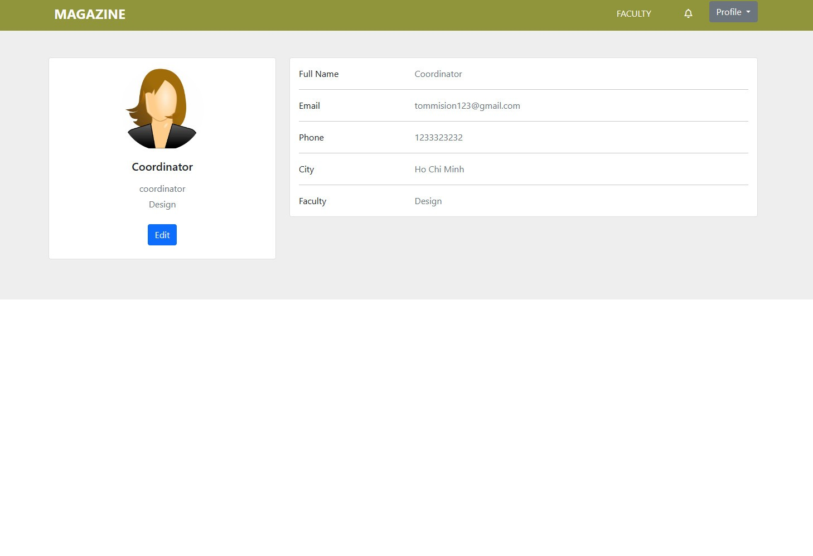

Login page



Marketing manager home page

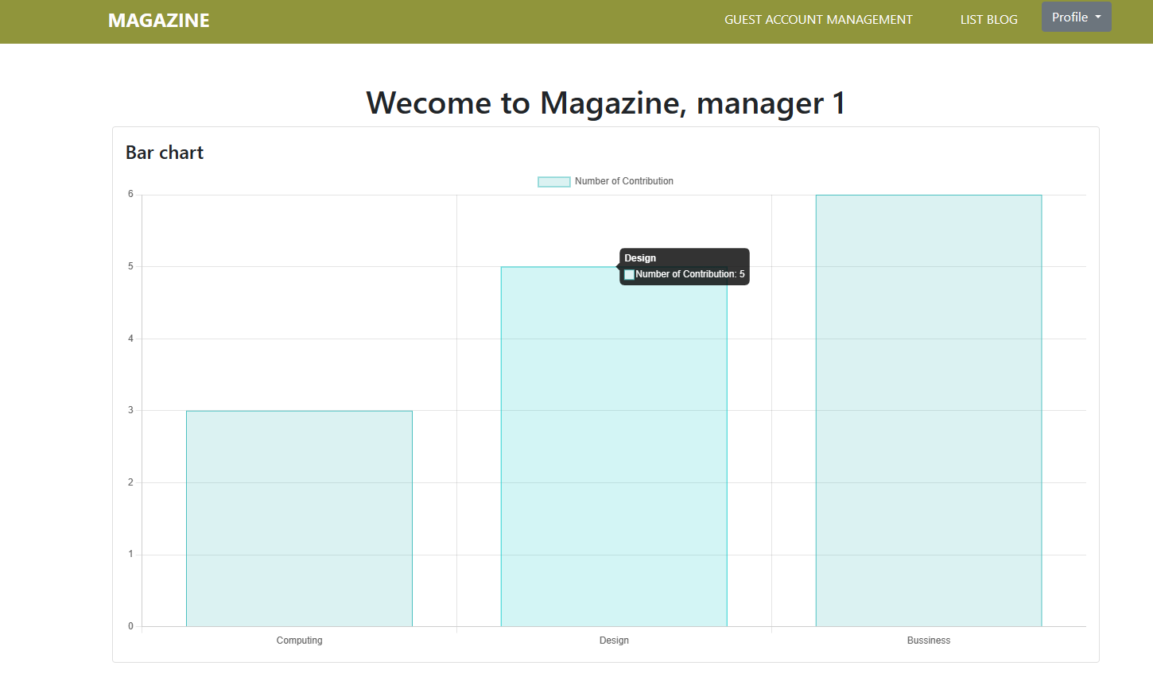

Management list guest account

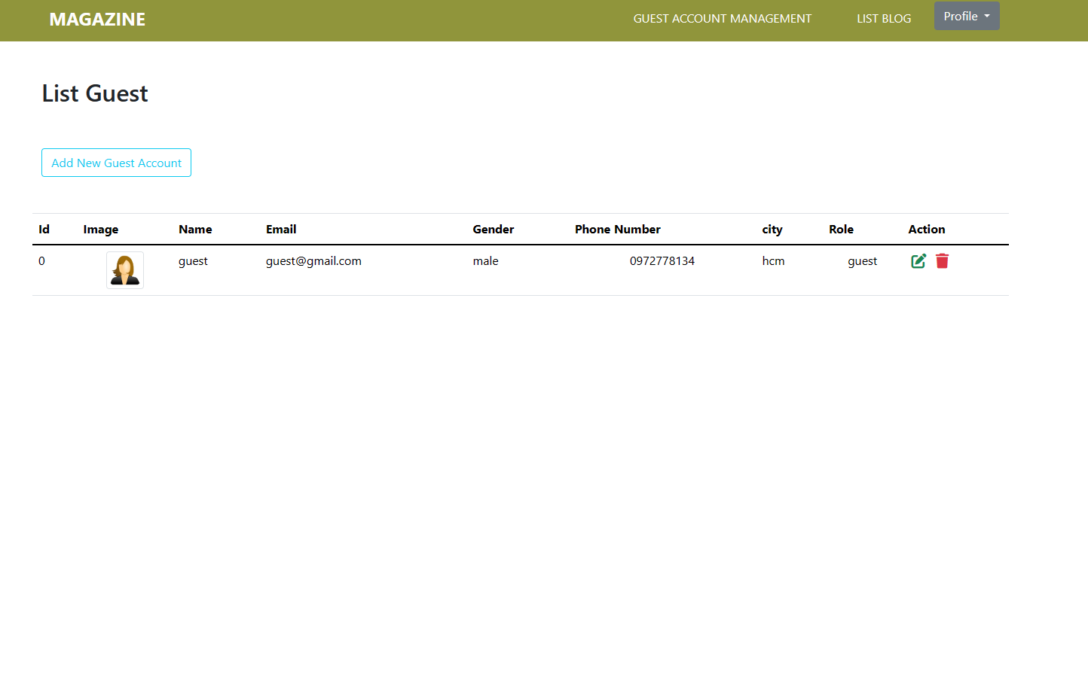

Add new guest account

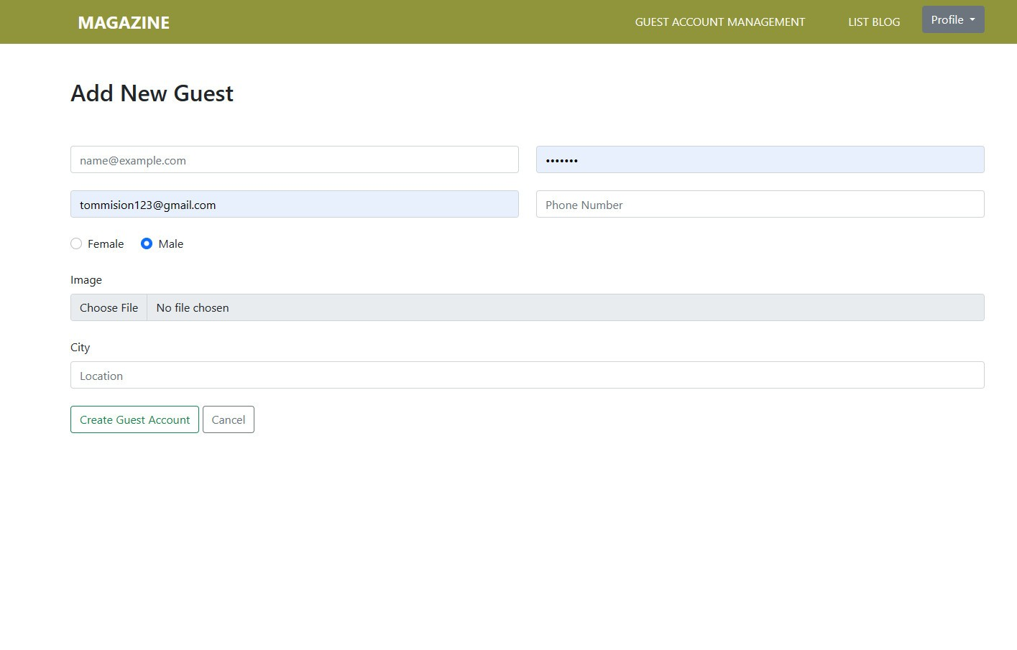

Home page for Guest

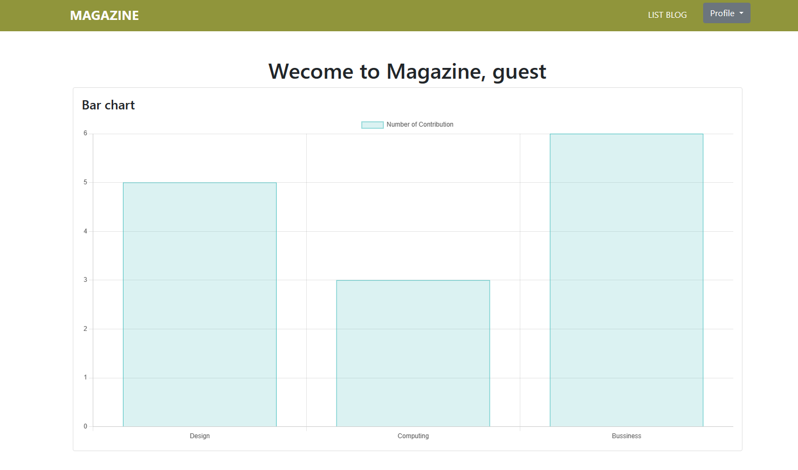

Guest view the published contributions

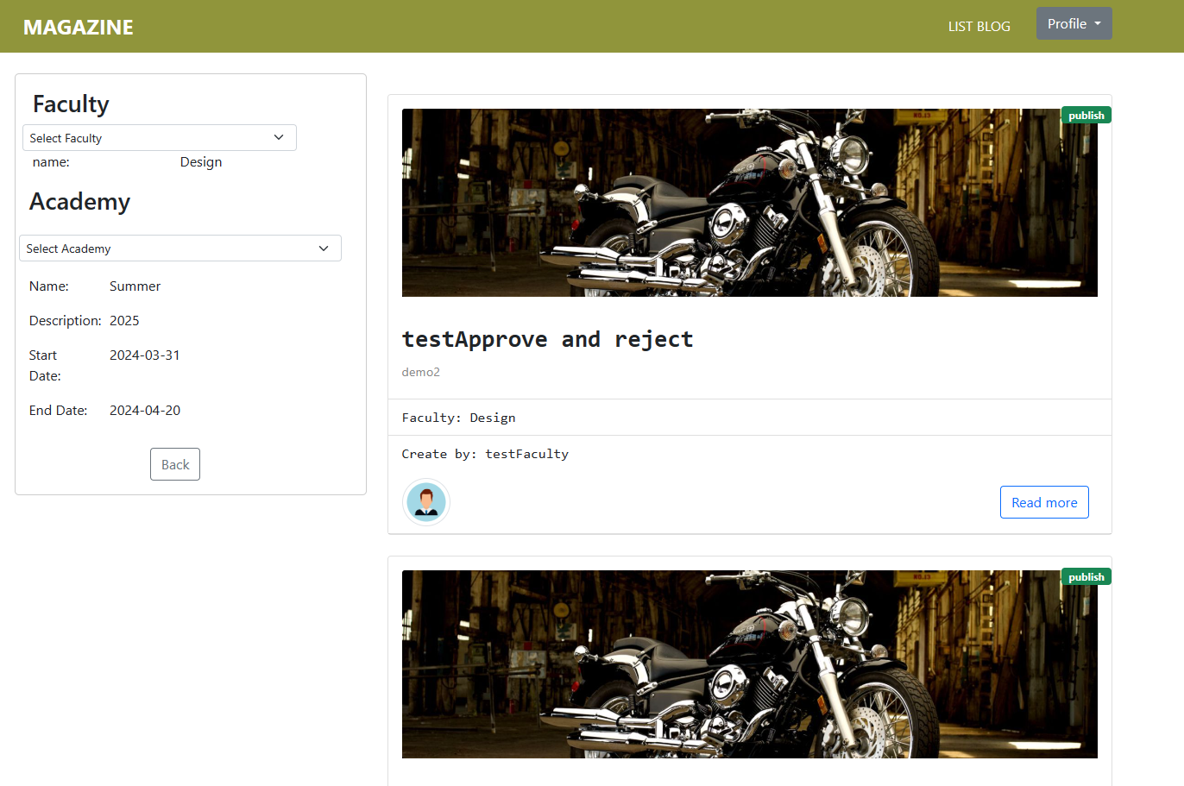

Student add a new contribution

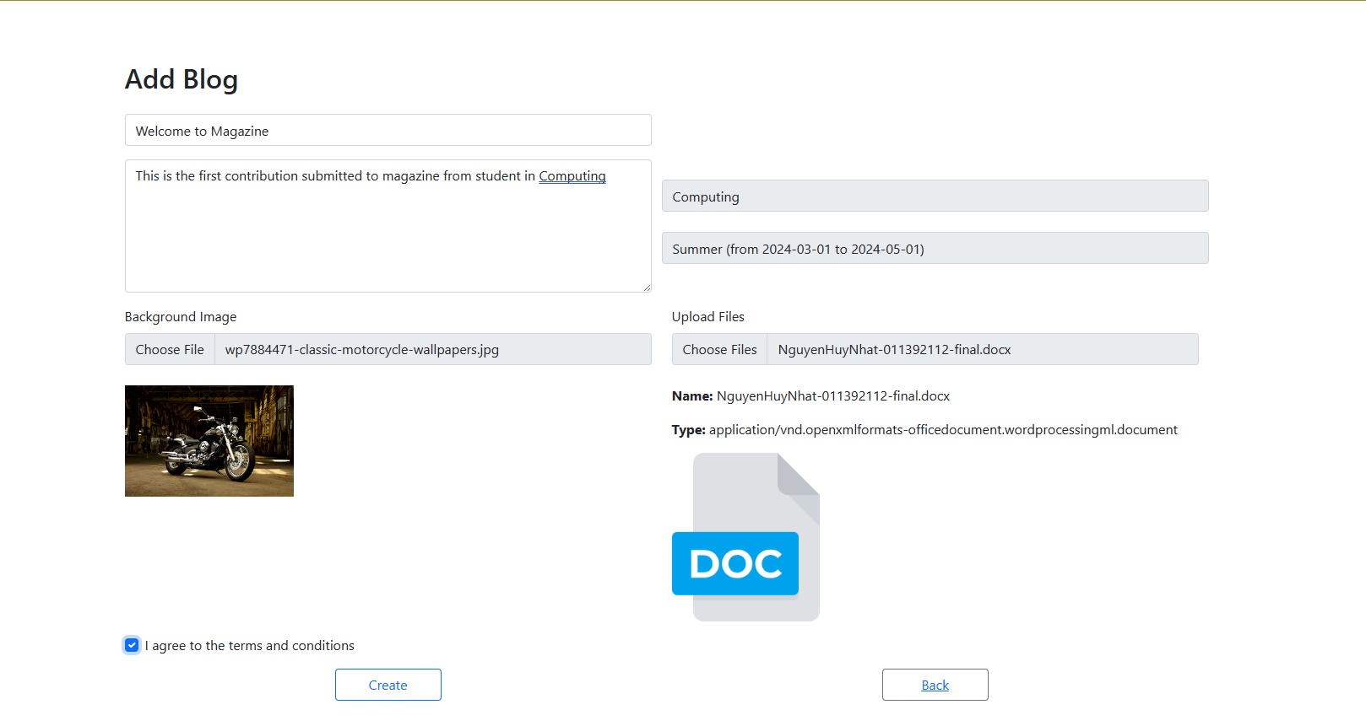

When student add a new contribution successfully

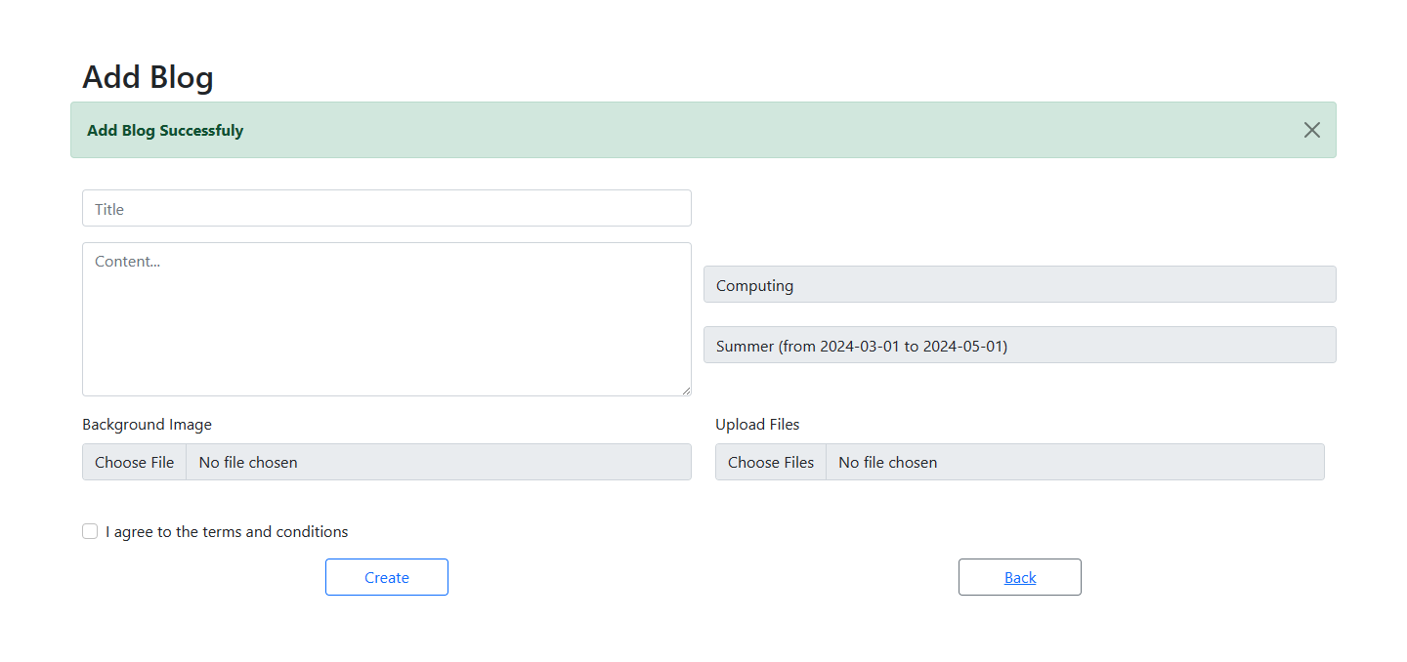

# 12. Links: Source Codes (Github), Screencast (Youtube/Google Drive/Onedrive)

# References: